AnyBackup Family 7.0.17.3
User Guide for D2C
July, 2022


© 2006 – 2022 AISHU Technology Corp.

All Rights Reserved. and other AISHU trademarks are registered by AISHU Technology Corp (AISHU), while all other trademarks are the property of their respective owners.
Note:
No part of this document may be copied, reproduced, transcribed or transmitted in any form by any means, without written permission from AISHU Technology Corp.
The content contained in this document may be added, removed or updated by AISHU Technology Corp. Prior notice will not be given for any changes. AISHU shall not be liable for technical or editorial errors or omissions contained herein. AISHU makes no warranties to all information, express or implied, in this document.

Content
Chapter 1 Overview 6
1.1 Introduction 6
1.1.1 Cloud Backup 6
1.1.2 Cloud Recovery 6
1.1.3 Data Cleanup 6
1.2 Applications Supported 6
1.3 Cloud Storages Supported 7
1.4 Restrictions 8
1.4.1 About Configurations 8
1.4.2 About Backup 8
Chapter 2 Checking Environment 9
2.1 Managing Licenses 9
2.1.1 AnyBackup CDM 7 9
2.1.2 AnyBackup CDM 7 for Huawei (Software, Resale) 9
2.1.3 AnyBackup Express 7 9
2.1.4 AnyBackup Enterprise 7 9
2.2 Checking Object Storage Backup Index Volume 10
2.3 Checking Preconditions of Cloud Storages 10
2.3.1 For HUAWEI CLOUD OBS 10
2.3.2 For Tencent Cloud COS 11
2.3.3 For Other Cloud Storages 12
2.4 Checking Cloud Storages 13
2.5 Checking Deduplication Volumes 13
Chapter 3 Best Practices for Cloud Storage Management 15
3.1 Managing Cloud Storages 15
3.1.1 Adding Cloud Storages 15
3.1.1.1 By System Administrators 15
3.1.1.2 By Tenants 17
3.1.2 Editing Cloud Storages 18
3.1.2.1 By System Administrators 18
3.1.2.2 By Tenants 19
3.1.3 Deleting Cloud Storages 20
3.1.3.1 By System Administrators 20
3.1.3.2 By Tenants 20
3.1.4 Enabling SSL Certificate Authentication for Cloud Storages 20
3.1.4.1 Enabling SSL Certificate Authentication 20
3.1.4.2 Editing SSL Certificate Authentication 23
3.2 Managing Permissions Cloud Storages 23
3.2.1 Assigning Operators by Security Administrators 23
3.2.2 Revoking Object Storages by Security Administrators 24
3.2.3 Assigning or Revoking Operators by Tenants 25
Chapter 4 Best Practices for Cloud Backup 26
4.1 Best Practices for Cloud Backup 26
4.1.1 Naming Rules 26
4.1.2 Creating Cloud Backup Jobs 26
4.1.3 Starting Cloud Backup Jobs 32
4.1.4 Editing Cloud Backup Jobs 33
Chapter 5 Best Practices for Cloud Recovery 35
5.1 Best Practices for Cloud Recovery 35
5.1.1 Creating Cloud Recovery Jobs 35
Chapter 6 Best Practices for Data Cleanup 42
6.1 Best Practices for Data Cleanup 42
Chapter 7 Best Practices for Cloud Disaster Recovery 45
7.1 Recovering via Self-backup Package 45
7.1.1 Solution 45
7.1.2 How to Recover 45
Chapter 8 About Configurations 46
8.1 About Configurations 46
Chapter 9 FAQs 47
9.1 Backup 47
9.2 Recovery 48
9.3 Others 48

- Overview

Introduction
This document is the user guide for D2C (Disk to Cloud), introducing how to properly use AISHU AnyBackup Family 7 to perform cloud backup and recovery. The precautions before and after deployment are also introduced.
    - Cloud Backup
Cloud Backup
It backs up the specified data sources (such as file) in production environment to cloud storages directly, such as HUAWEI CLOUD OBS, Tencent Cloud COS and DELL EMC.
    - Cloud Recovery
Cloud Recovery
It recovers data directly to production environment based on the cloud backup jobs if data is damaged or lost.
    - Data Cleanup
Data Cleanup
Operators are allowed to clean all or specified backup data generated in the jobs created by himself in his cloud storage.

Applications Supported
For applications supported, see AISHU AnyBackup Family 7 Software Compatibility List.

Cloud Storages Supported

Cloud Storages | Support or Not | Remarks
HUAWEI CLOUD OBS |  | Compatible with HUAWEI Public Cloud.
HUAWEI FusionStorage Object |  | Compatible with HUAWEI Private Cloud.
Tencent Cloud COS |  | Compatible with Tencent Public Cloud. Tencent Private Cloud is not tested.
Alibaba Cloud OSS |  | Compatible with Alibaba Public Cloud. Alibaba Private Cloud is not tested.
BC-ONest
UniCloud
DELL EMC
ECeph
Wo Cloud
Qing Cloud
Inspur Cloud
AWS
Microsoft Azure
China Telecom OOS
Kingsoft Cloud KS
Baidu Cloud
UCLOUD
China Mobile Cloud
OTC (Deutsche Telekom)
Others |  | Those support S3 protocol but not listed in this table.
XSKY XEOS
SandStone MOS

Restrictions
    - About Configurations
- Data can be backed up to standard buckets only (Data cannot be backed up to archive buckets or infrequent access buckets).
- If backing up to HUAWEI Private Cloud, the domain names of global, defaultRegion and cluster must be the same (for example, obs.defaultregion.com), otherwise the connection will fail.
- Configure at least 2GiB for object storage backup index volume, because 1GiB will be reserved. 50GiB or above is recommended.
    - About Backup
- For cloud storages that transfer data in Server mode, the maximum number of job concurrency supported by cloud backup is 10, otherwise the point in time deletion may fail.
- For cloud storages that transfer data in Client mode, the maximum number of job concurrency supported by a single-node server is 30.
- If there is a data cleanup job using the same fingerprint library, the D2C job will be in Waiting, and the data transferred is 0. Wait until the cleanup job finishes and the D2C job will continue.
- If different object storages are used for the D2C job with deduplication enabled, the same fingerprint library cannot be used.
- Checking Environment

Managing Licenses
    - AnyBackup CDM 7
- Trial License: Cloud backup can be performed for 90 or 360 days.
- Perpetual License: Essential Module for AnyBackup CDM + Front-end/Back-end Backup Agent + Cloud Backup Agent.
- Subscription Service: Access the EUOP system to synchronize subscription information.
    - AnyBackup CDM 7 for Huawei (Software, Resale)
- HUAWEI Standard Backup License.
    - AnyBackup Express 7
- Trial License: Cloud backup can be performed for 90 or 360 days.
- Perpetual License: Essential Module for AnyBackup Express + Front-end/Back-end Backup Agent + Cloud Backup Agent.
- Subscription Service: Access the EUOP system to synchronize subscription information.
- AnyBackup Express Software Subscription Service (optional features – licensed by EUOP).
- Express Package Software Subscription Service (full features – licensed by EUOP).
- Express Package Software Subscription Service (full features – license assigned by AMS).
    - AnyBackup Enterprise 7
- Perpetual License: Essential Module for AnyBackup Enterprise + Front-end/Back-end Backup Agent + Cloud Backup Agent.
- Subscription Service: Access the EUOP system to synchronize subscription information. Full features – license assigned by AMS, full features – licensed by EUOP, optional/non-optional features – licensed by EUOP are supported.

Checking Object Storage Backup Index Volume
Log into the console as a system administrator and check. Make sure the object storage backup index volume is created on at least one node. Click Storage > Node Management and select the node. Click Configure > Volume Management > Object Storage Backup Index Volume to check.
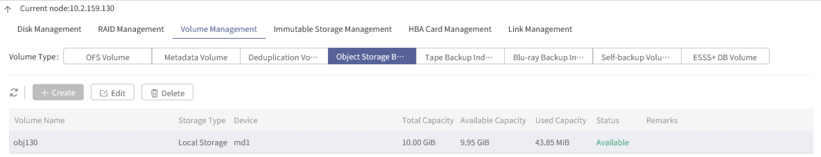

- Mind the following:
- Object storage backup index volume needs to be added before cloud backup.
- Only one object storage backup index volume can be added on one node. Make sure object storage backup index volume is added on at least one node in a cluster environment.
- When editing object storage backup index volume, the space cannot be diminished.
- Object storage backup index volume cannot be deleted if there is data.

Checking Preconditions of Cloud Storages
    - For HUAWEI CLOUD OBS
- You have registered a HUAWE CLOUD OBS account and the payment is done.
- Log into the console of HUAWEI CLOUD OBS, and create Bucket.
- Get the service host of Bucket.
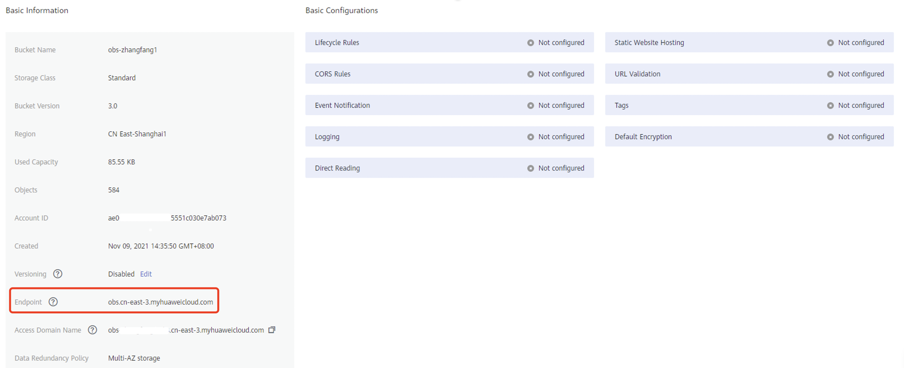

- Get the ID, key of cloud storage.
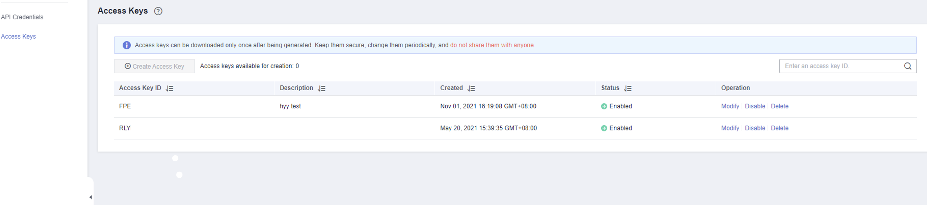

- After the access key is added, a text document will be generated with related ID, key. Or you can get the ID, key from the administrator.
    - For Tencent Cloud COS
- You have registered a Tencent Cloud COS account and the payment is done.
- Log into the console of Tencent Cloud COS, and create Bucket.
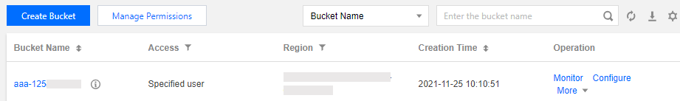

- Get the service host of Bucket.
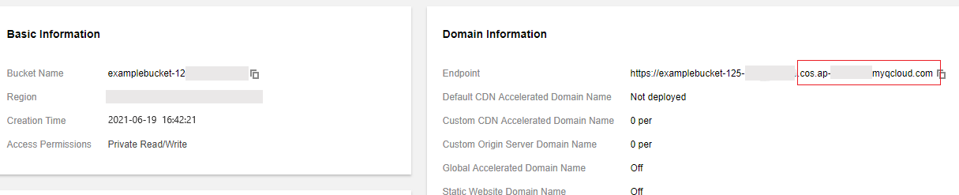

- Get the ID, key from the administrator.
- The account shall have administrator permission and list permission, that is, Bucket list can be got.
    - For Other Cloud Storages
Alibaba Cloud: Log in to Alibaba Cloud, click Console, choose your username on the upper right to get the Access Key.
DELL EMC: Log in to EMC, click Users > Show Secret Key to get the S3 Secret Key.
ECeph: Log in to ECeph, click Users > Show Secret Key to get the S3 Secret Key.
Wo Cloud: Log in to the console, click Object Storage > Secret Key Management to get the Secret Key.
QingCloud: Log in to QingCloud, click Console > API Key > Create and enter the name, click Submit > Download.
AWS: Log in to AWS, choose your username on the upper right, click Security Credentials > Dashboard > Rotate your access keys > Manage User Access Keys > Security credentials.
Microsoft Azure: Log in to Microsoft Azure, click Storage Account > Set > Access Key.
ChinaTelecom OOS: Log in to OOS, click Cloud Computing > Storage > Object Storage > Console, choose your account on the upper right, click Account Management > API Key > Create AccessKey.
Kingsoft Cloud KS: Log in to Kingsoft Cloud, click Console on the upper right, click Identity and Access Management on the left bar, choose your account, click Secret Key > Generate Secret Key.
Baidu Cloud: Log in to Baidu Cloud, choose your user name on the upper right to get the Access Key.
UCLOUD: Log in to UCLOUD, click Console on the upper right, click API Key > Display or Reset your secret key.
China Mobile Cloud: Log in to China Mobile Cloud, click Console > mCloud Management Console on the upper right, click Resources > EOS > Accounts and Subaccounts to check your AccessKey and SecretKey.

Checking Cloud Storages
Log in to the console as a system administrator and click Resources > Object Storage > Storage Media to check whether the cloud storage is added. If yes, make sure the cloud storage is assigned to the operator or tenant.
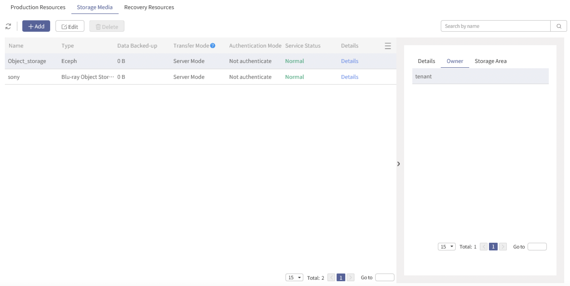

For detailed configurations and management for cloud storages, see Chapter 3.

Checking Deduplication Volumes
To check configurations for jobs on which deduplication will be enabled,
- Log into the console as a system administrator and check. Make sure the deduplication volume is created on at least one node. Click Storage > Node Management and select the node. Click Configure > Volume Management > Deduplication Volume to check.
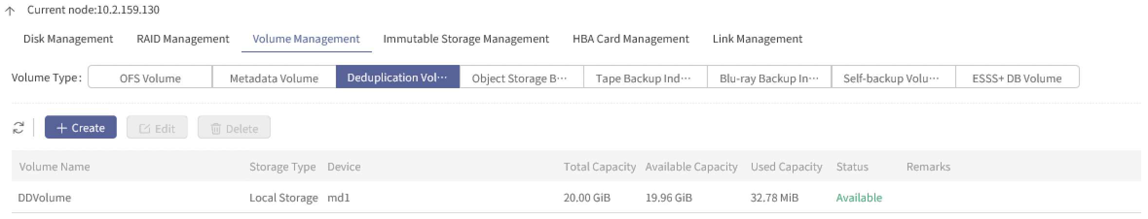

- Click Resources > Deduplication to check the fingerprint pool. If no fingerprint pool is found, create one (make sure a deduplication license has been added first). Select a fingerprint pool and you can see the owner. If there is no owner, contact the security administrator to log in to the Console and click Resources > Deduplication to assign the fingerprint pool.
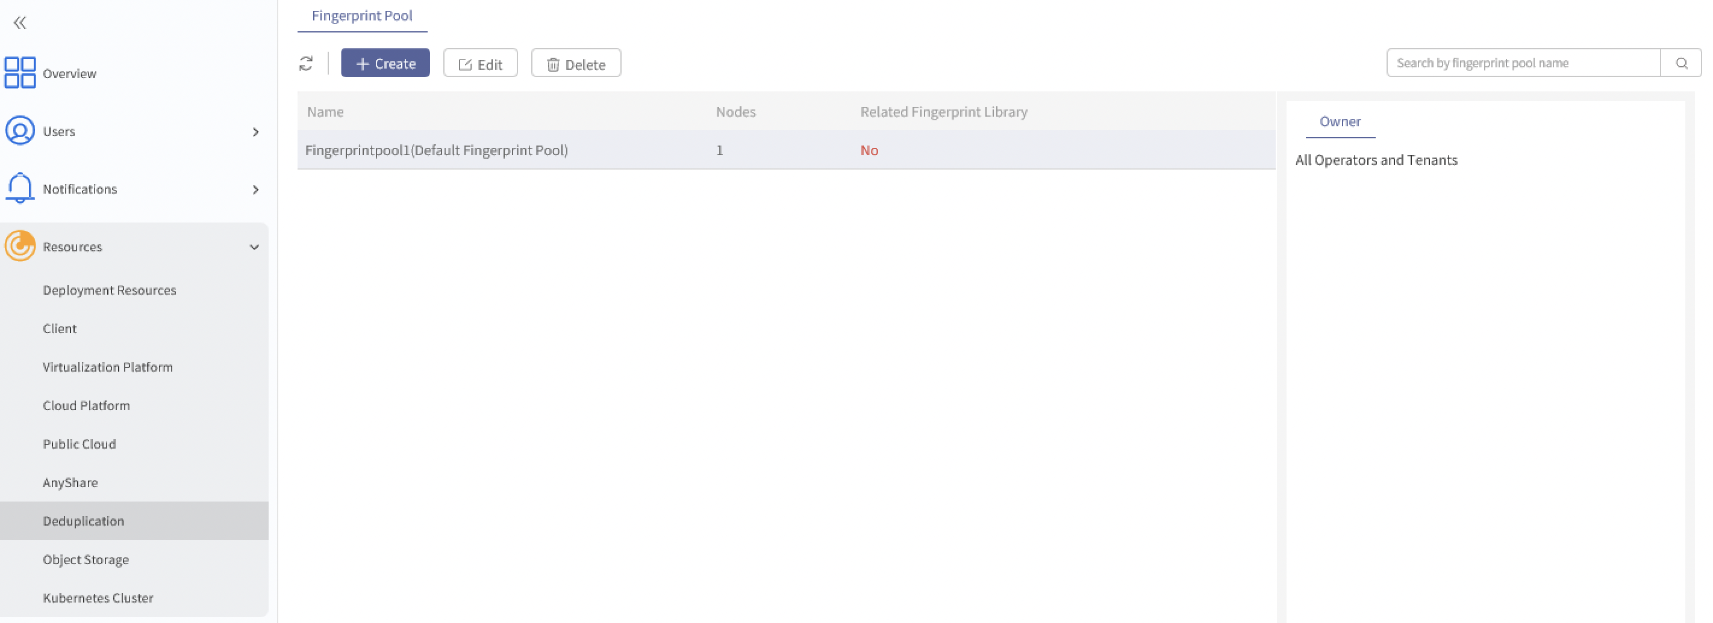

- Best Practices for Cloud Storage Management

Managing Cloud Storages
    - Adding Cloud Storages
      - By System Administrators
- Log in to the Console as a system administrator and click Resources > Object Storage > Storage Media. Then, click Add and enter the information required in the pop-up window.
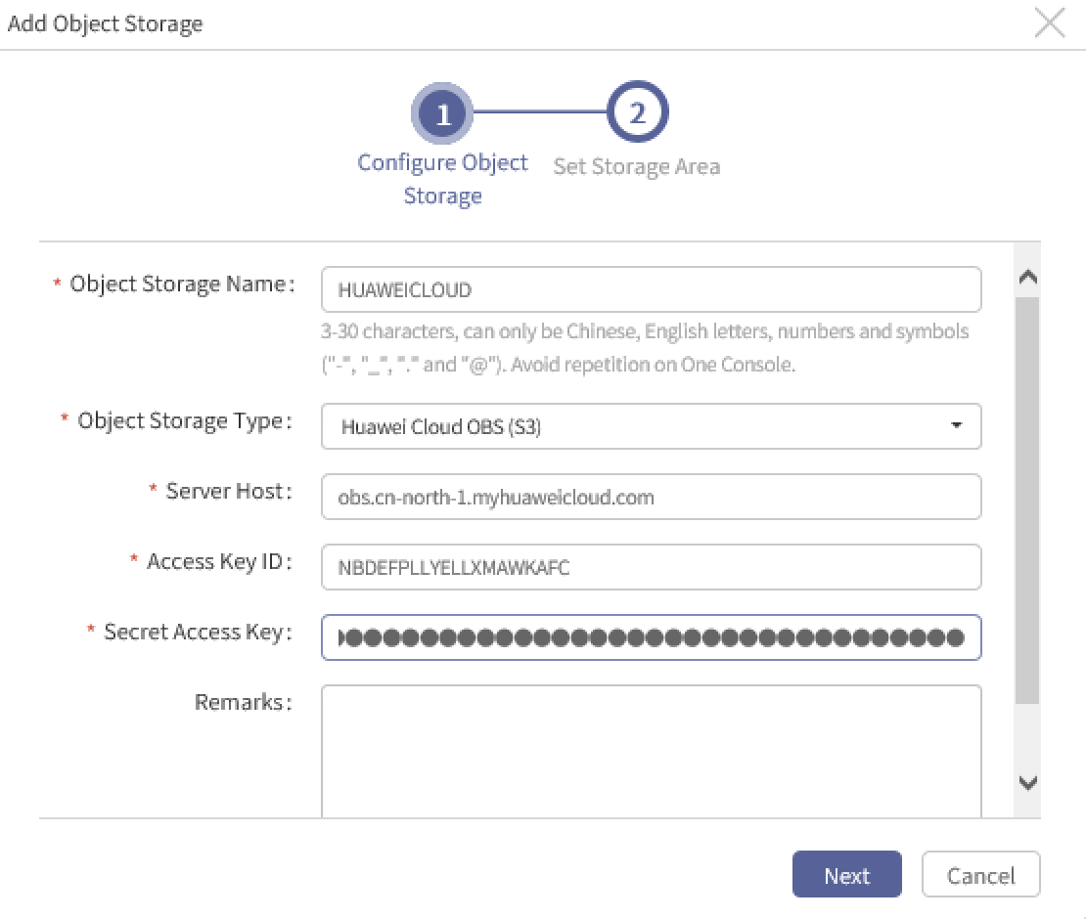

  - Name: Required. It is empty by default.
  - Type: Required. All compatible object storages are listed in the drop-down list.
  - Service Host: Required. It can be viewed in the cloud account.
  - Access Key ID: Required. It is the access ID for cloud storage tenants.
  - Secret Access Key: Required. It is the access password for cloud storage tenants.
  - Description: Optional.
- After the information of cloud storage is entered, click Next to configure Bucket. Open the switch to get the Bucket list and configure Bucket.
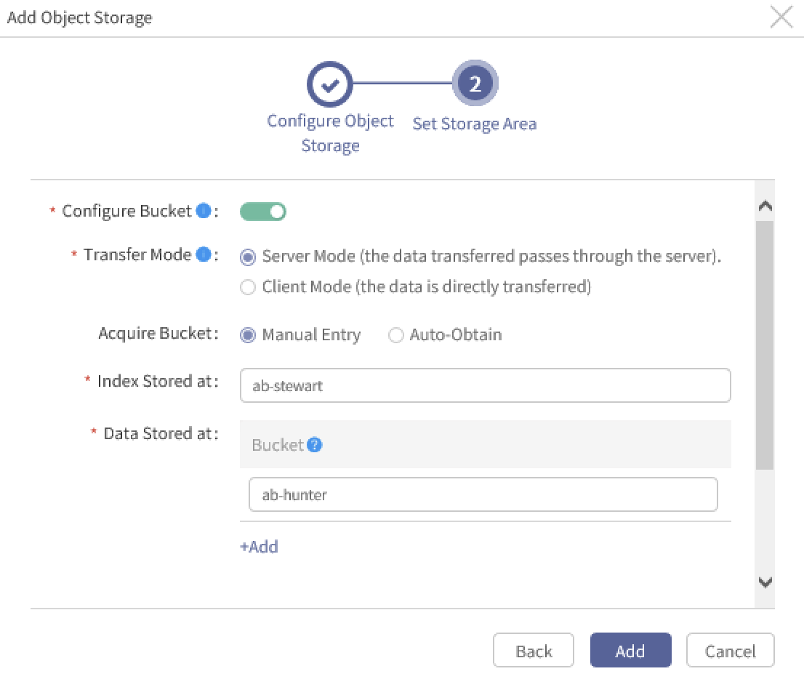

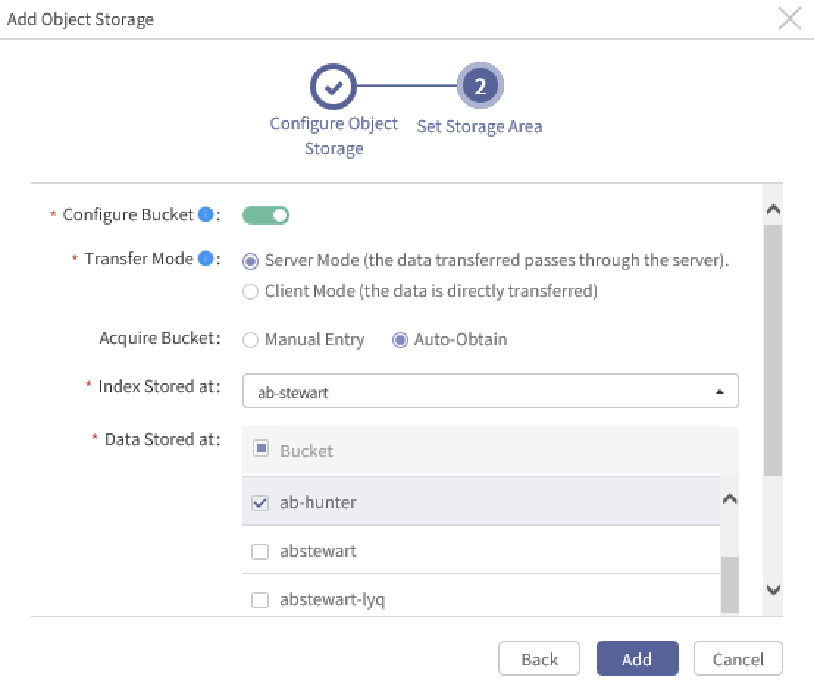

  - Transfer Mode: Server Mode by default, which means that data transfer between Client and Cloud Storage will be transited through Server End. If Client Mode is chosen, data can be transferred between Client and Cloud Storage directly.
  - Acquire Bucket: Manual Entry by default. You can enter the name of an existing bucket to store index and data. Multiple data storage locations can be specified. If you choose Auto-Obtain, the buckets can be acquired automatically.
- Mind the following: For a single-node server, at most 30 concurrent jobs are supported for cloud storages using Client Mode. At most 10 concurrent jobs are supported for cloud storages using Server Mode.
  - Index Stored at: Select one Bucket to store index data.
  - Data Stored at: Select at least one Bucket to store backup data.
- After the bucket is selected, click Add and the cloud storage is added successfully.

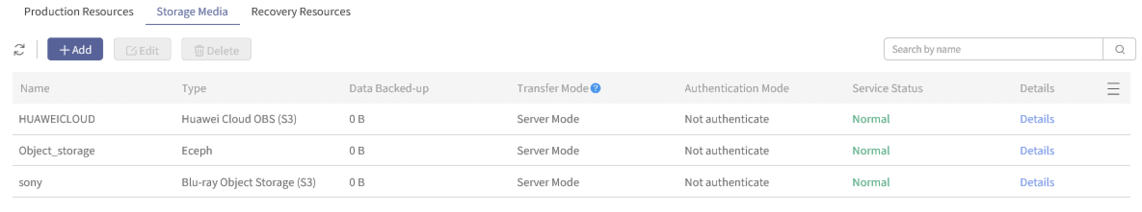

      - By Tenants
- Log into the console as a tenant and click Resources > Object Storage > Storage Media and click Add to add the cloud storage.
- The following procedures are same with that processed by system administrators.
- Mind the following: After the cloud storage is added, the Tenant will be defaulted as the owner.
    - Editing Cloud Storages
      - By System Administrators
- Log in to the Console as a system administrator and click Resources > Object Storage > Storage Media. Select the cloud storage and click Edit.
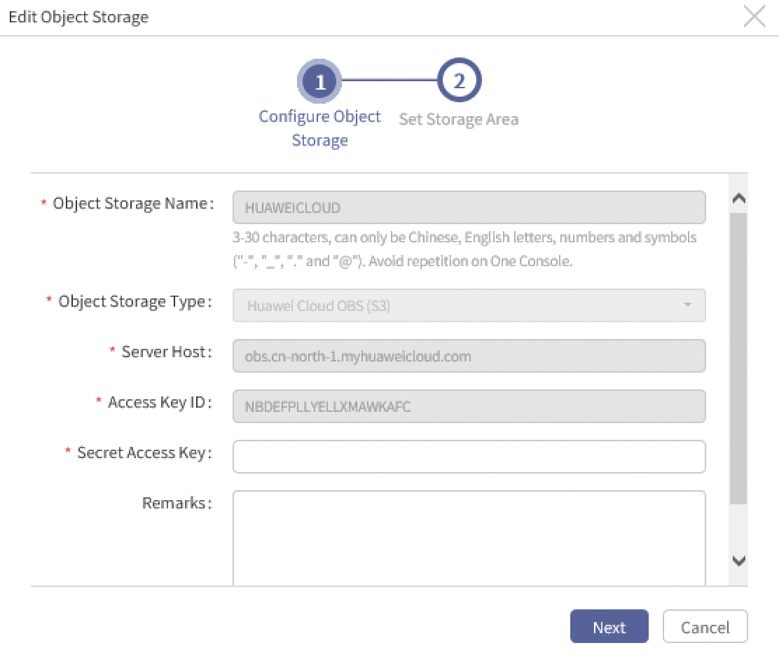

  - Name: Cannot be edited.
  - Type: Cannot be edited.
  - Service Host: Cannot be edited.
  - Access Key ID: Cannot be edited.
  - Secret Access Key: Required. It is the access password for cloud storage tenants.
  - Description: Optional.
- After the information of cloud storage is entered, click Next to get the Bucket list and set storage area.
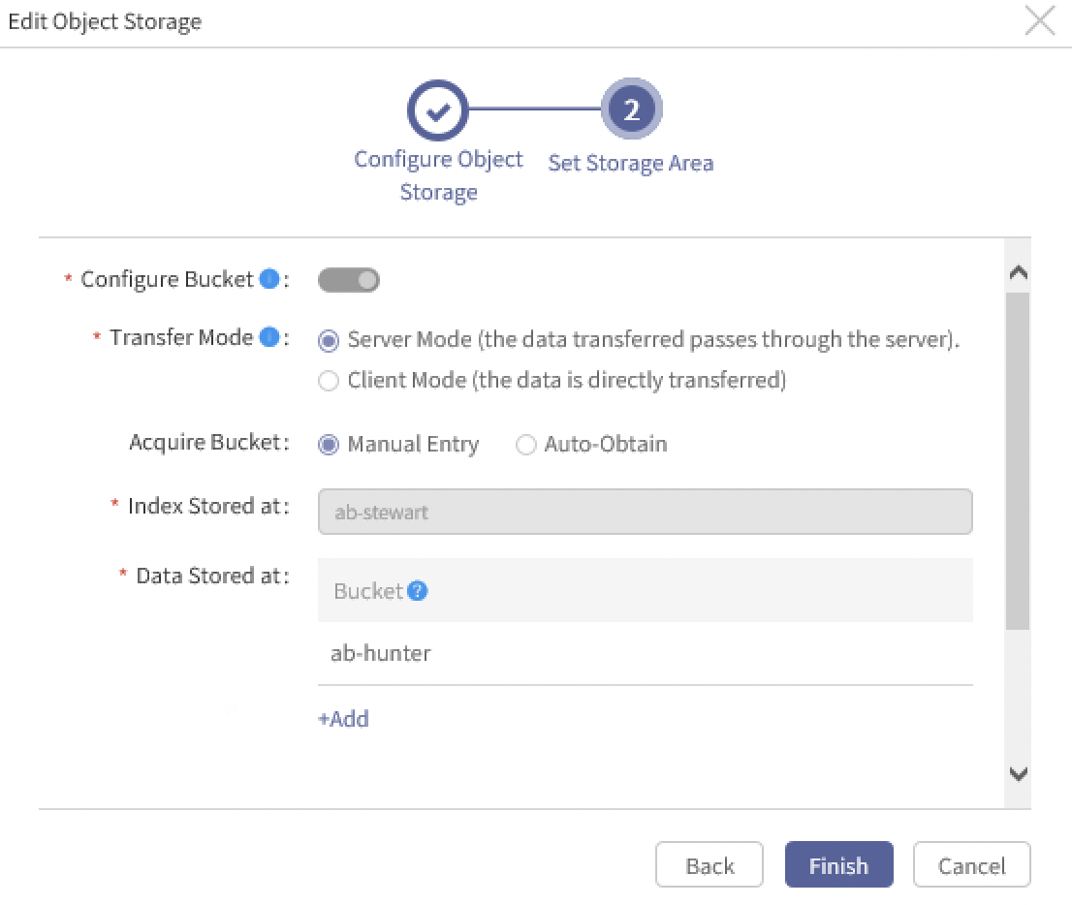

  - Configure Bucket: Cannot be edited. The switch is enabled.
  - Transfer Mode: Server Mode or Client Mode can be chosen.
  - Bucket: Manual Entry or Auto-Obtain can be chosen.
  - Index Stored at: Cannot be edited. The Bucket is already selected.
  - Data Stored at: New Buckets can be added, but the selected one cannot be canceled.
- After the storage area is selected, click Finish and the cloud storage is edited successfully. The new configuration will take effect in the next backup job.
      - By Tenants
- Log into the console as a tenant and click Resources > Object Storage > Storage Media. Choose the cloud storage and click Edit.
- The following procedures are same with those processed by system administrators.
- Mind the following: Tenants CANNOT edit the cloud storages added by system administrators.
    - Deleting Cloud Storages
      - By System Administrators
- Log into the console as a system administrator and click Resources > Object Storage > Storage Media. Select the cloud storage and click Delete.
- Enter YES. Click Delete and the cloud storage can be deleted successfully.
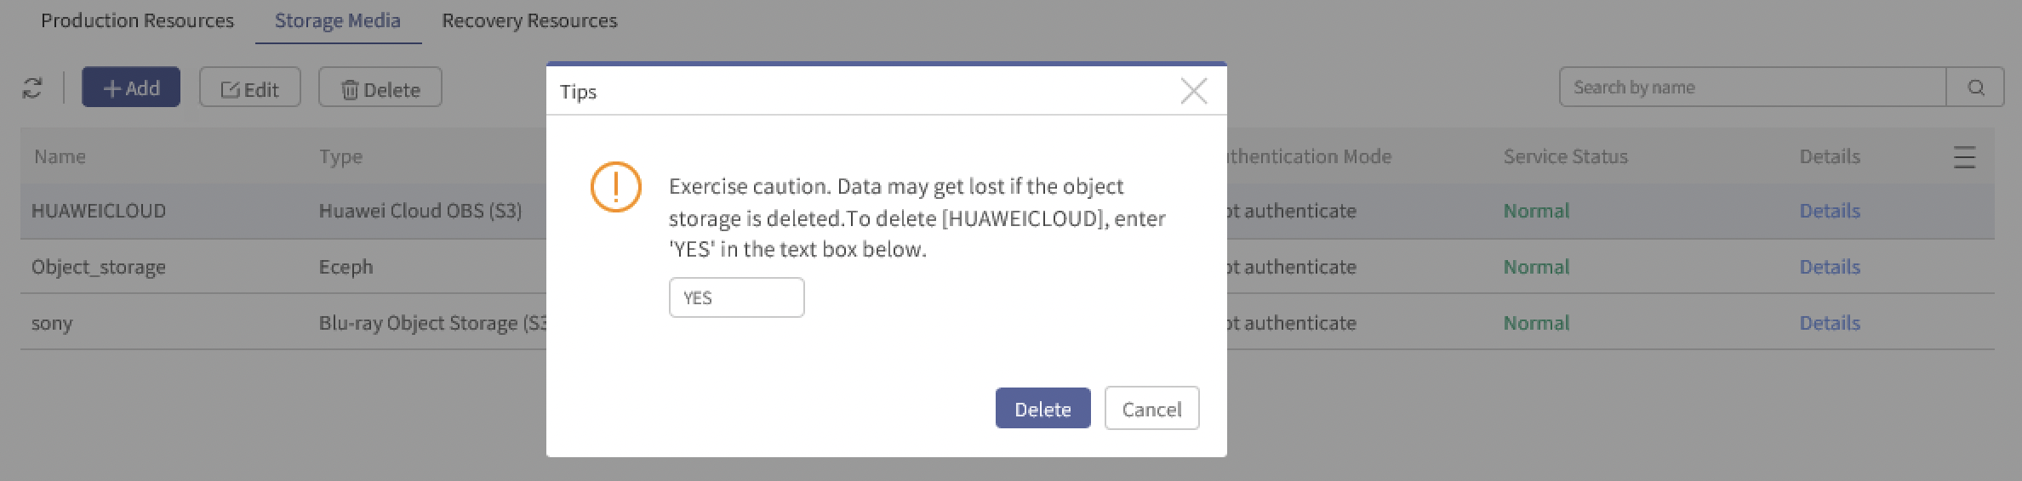

- Mind the following: Cloud storages assigned to tenants or operators CANNOT be deleted.
      - By Tenants
- Log into the console as a tenant and click Resources > Object Storage > Storage Media. Select the cloud storage and click Delete.
- The following procedures are same with those processed by system administrators.
- Mind the following:
- Tenants CANNOT delete the cloud storages added by system administrators.
- Only when the owner of the cloud storage added by tenants is only the tenant himself can the cloud storage be deleted by the tenant.
    - Enabling SSL Certificate Authentication for Cloud Storages
      - Enabling SSL Certificate Authentication
- Log into the console as a system administrator or a tenant and click Resources > Object Storage > Storage Media. Click Add and Add Object Storage window will pop up. Use https protocol for service hosts.
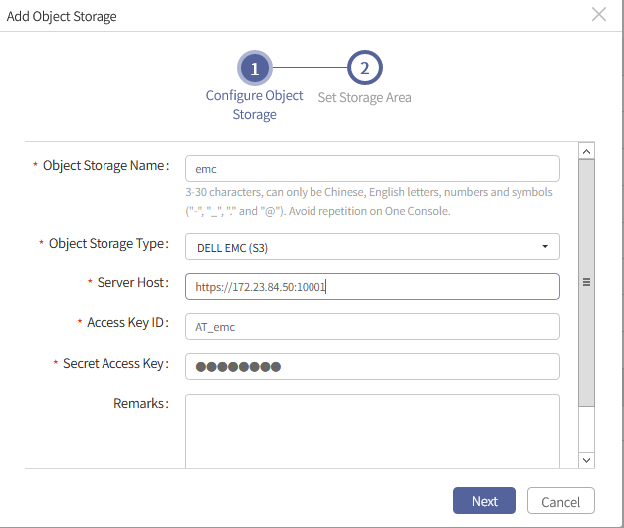

- Click Next to authenticate certificate.
- If the certificate is trusted, the next page will be entered directly.
- If the certificate is fake (for example, the certificate is from an untrusted CA) or not trusted (for example, the certificate is expired), a window will pop up. If the certificate is fake, select to trust this certificate or not authenticate this certificate. If the certificate is untrusted, select not to authenticate this certificate.
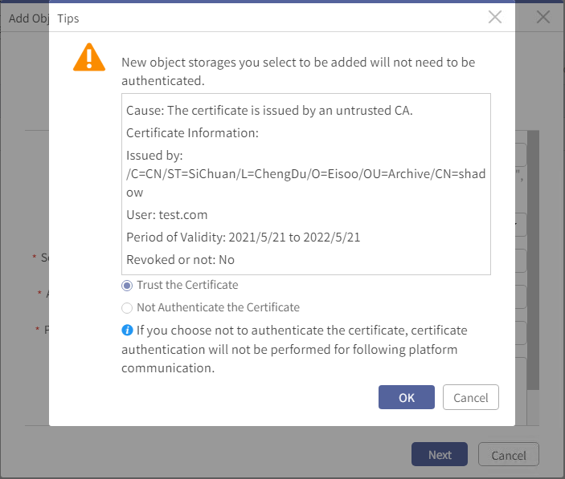

- Click Continue to enter Configure Bucket page. Open the Bucket switch and select the Index Stored at and Data Stored at and then click Add.
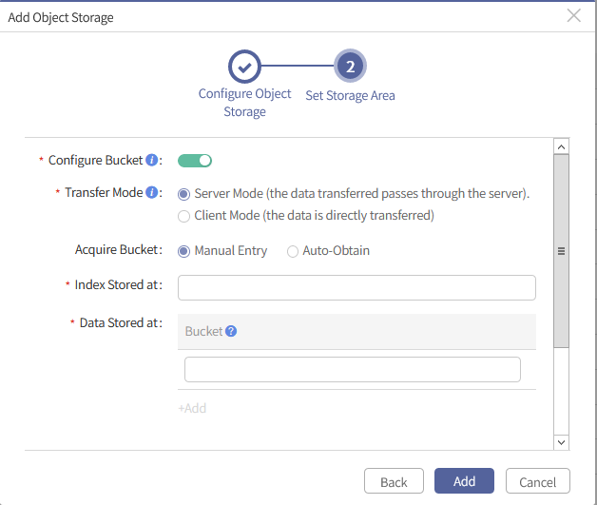

- View the storage media list to check whether the SSL Certificate Authentication is enabled for the cloud storage in Authentication Mode.
      - Editing SSL Certificate Authentication
- Log into the console as a system administrator or a tenant and click Resources > Object Storage > Storage Media. Select the cloud storage connected by https protocol and click Edit.
- Enter the access password and click Next. If the certificate is trusted, see Chapter 3.1.2. If the certificate is fake or untrusted, the following window will pop up.
- If the certificate is fake, the authentication mode can be edited. Select to trust the certificate or not to authenticate the certificate. If the certificate is untrusted, the authentication mode CANNOT be edited. Click Continue to enter Edit Object Storage page and select the Bucket.
- After the bucket is edited, click Finish to back to the storage media list. Check whether the authentication mode of the cloud storage is changed.

Managing Permissions Cloud Storages
    - Assigning Operators by Security Administrators
- Log into the console as a security administrator and click Resources > Object Storage > Storage Media. Select the cloud storage and click Assign.
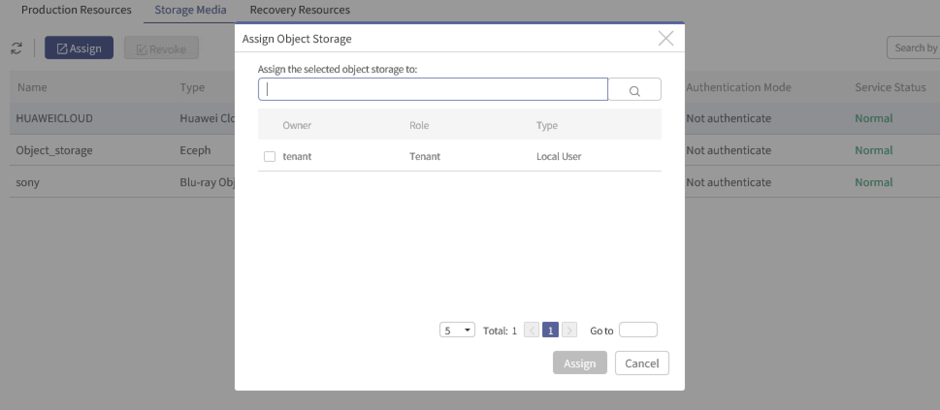

- Mind the following: Only operators or tenants not disabled will be displayed in the user list here.
- Select one or multiple users, click Assign and the object storage is assigned successfully.
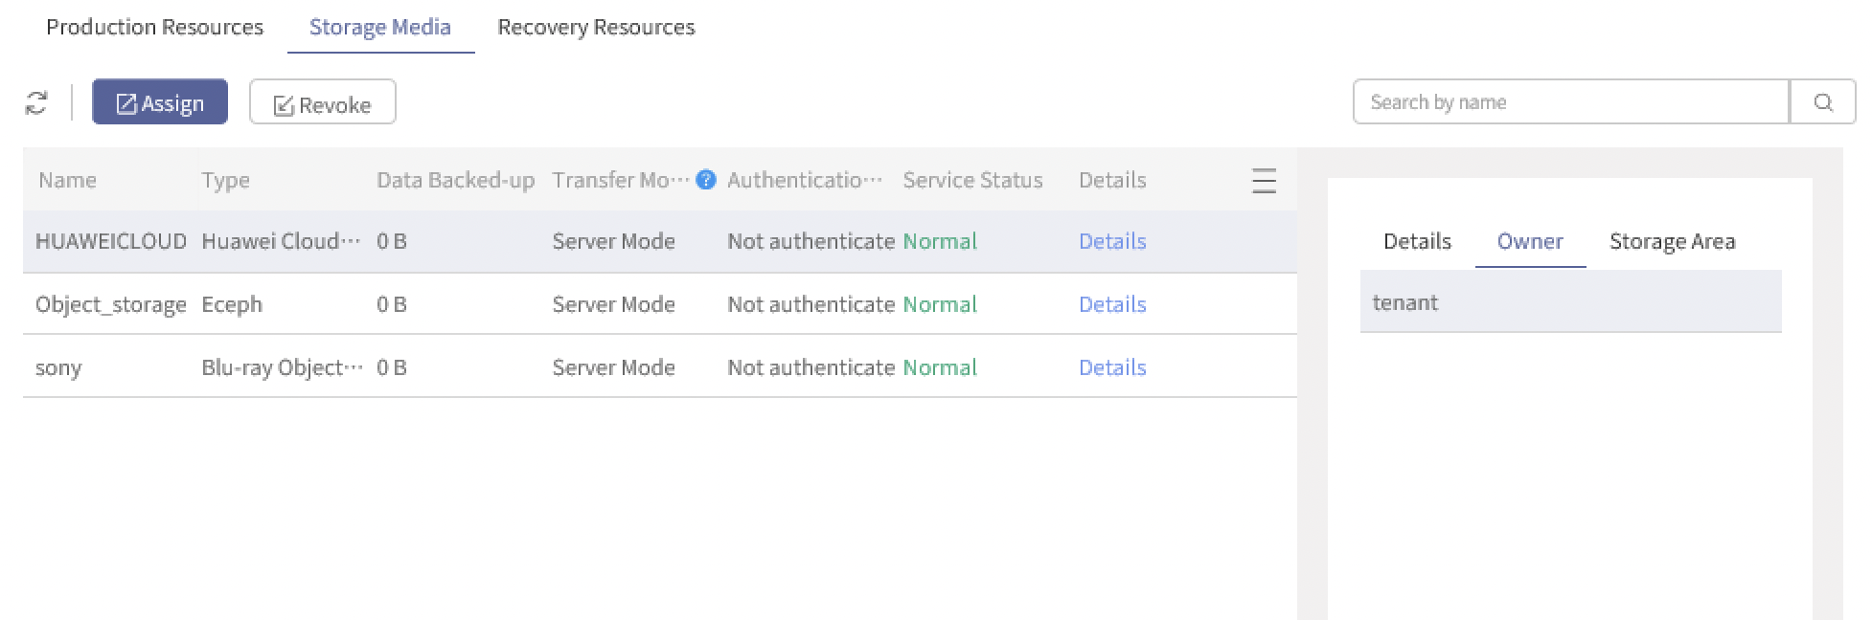

    - Revoking Object Storages by Security Administrators
- Log into the console as a security administrator and click Resources > Object Storage > Storage Media. Select the cloud storage which is already assigned to a tenant or an operator and click Revoke.
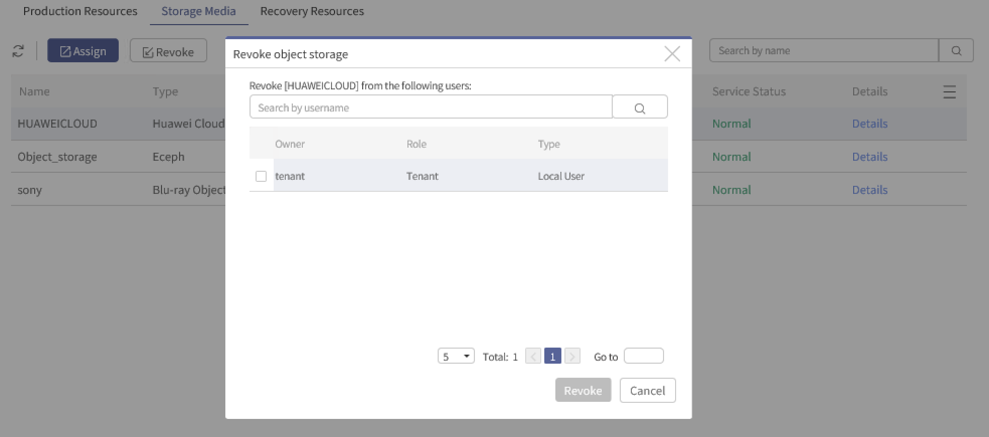

- Mind the following: The cloud storage cannot be revoked if there is a job running.
    - Assigning or Revoking Operators by Tenants
- Log into the console as a tenant and click Resources > Object Storage > Storage Media and assign the cloud storages created by the tenant himself or the cloud storages assigned by security administrator to the operator created by the tenant himself. Or the tenant can revoke the cloud storage.
- The procedures are same with those processed by security administrators.
- Mind the following: Tenants can only assign and revoke cloud storages to/from the operators created by the tenant himself.
- Best Practices for Cloud Backup

Best Practices for Cloud Backup
This documentation takes file backup as an example. For other applications, see Best Practices. For example, if you want to perform Oracle backup, see AISHU AnyBackup Family 7 Best Practices for Oracle Backup and Recovery.
    - Naming Rules
- For Usernames: It shall be comprised of Chinese, uppercase and lowercase letters, numbers, and "-", "_", ".", "@", with 3~30 characters, not repeated globally.
- For Job Groups and Jobs: It shall be comprised of Chinese, uppercase and lowercase letters, numbers, and "-", "_", ".", "@", with 3~256 characters, not repeated globally.
- For Emails: It can only be comprised of A~Z, a~z, 0~9 and @.-_, for example, yourname@domain.com, within 50 characters.
- For Remarks: The type is not limited, but the length shall be within 50 characters.
    - Creating Cloud Backup Jobs
- Log into the console as an operator or a tenant and click Backup and Recovery > Data Backup > Create. Select Data-Level Backup Job and choose the object to be protected. Select Client > File System.
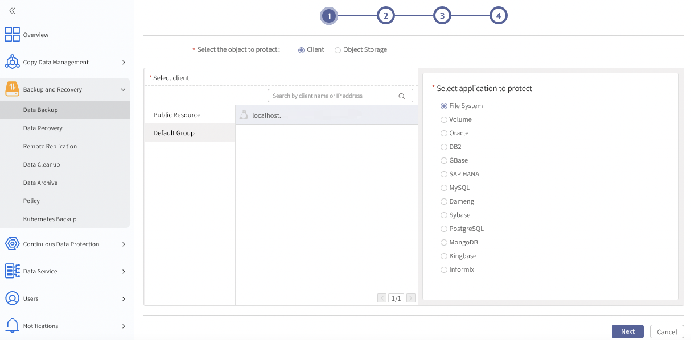

- Click Next. Data sources can be discovered automatically in file backup jobs. After the system disk files are browsed, click + to unfold and the files or folders can be selected as the data source.
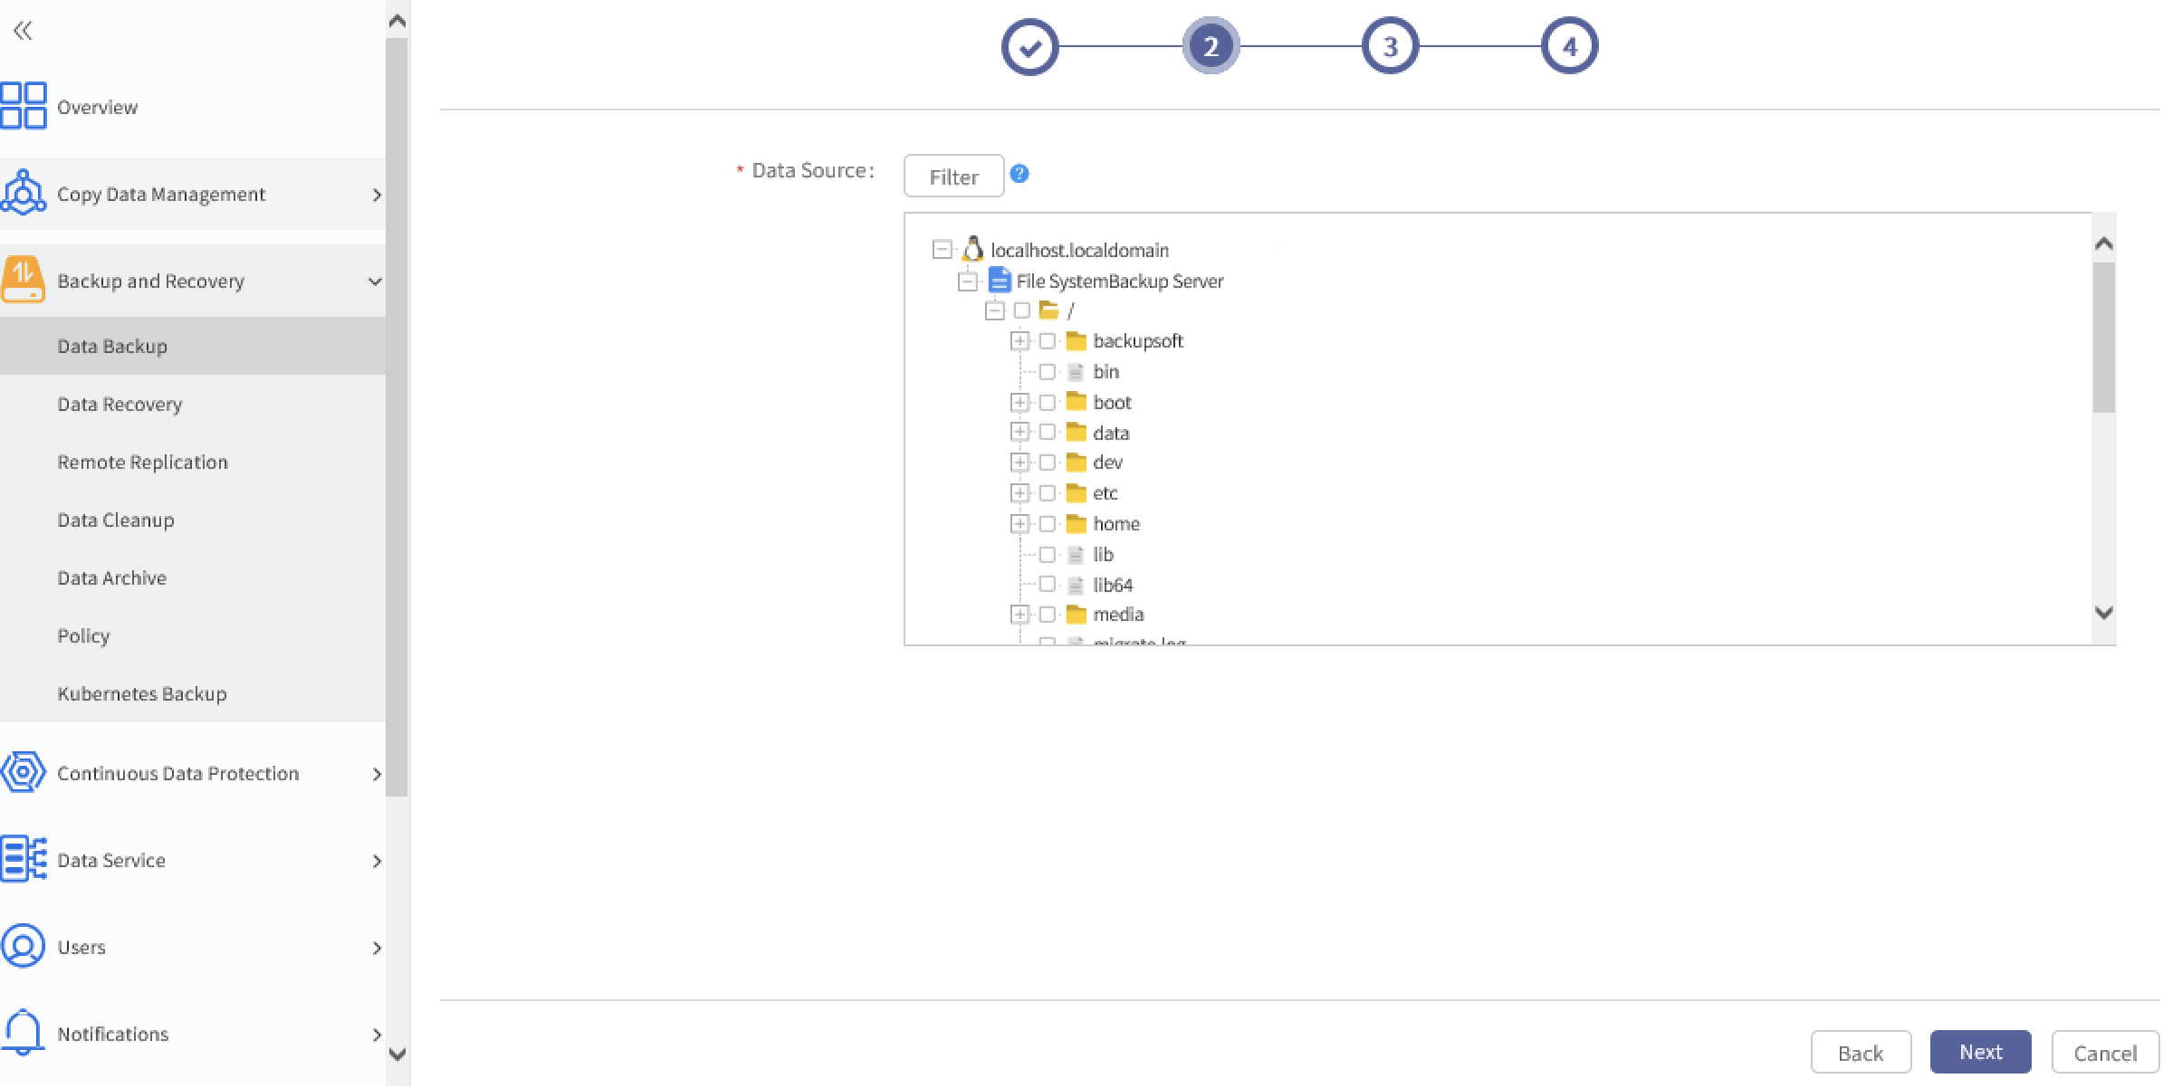

- Mind the following:
- A maximum of 100 data sources can be unfolded and displayed at the first time. To see more data sources, click More.
B. For backup efficiency, the same file is NOT recommended in two backup jobs.
C. For data filter rules, see AISHU AnyBackup Family 7 Best Practices for File System Backup and Recovery.
- Click Next to configure Backup Media and Options.
  - Storage Media: Select the object storage. The drop-down list displays the cloud storages assigned to operators. The abnormal cloud storages will be marked Abnormal.
  - Backup Option: The following options can be configured.
- Transfer and Storage Encryption: Disabled by default. If it is enabled, you can choose AES256 algorithm or SM4 algorithm (AES256 by default), then the data will be encrypted both in storage and in transfer.
- Data Compression: Disabled by default. If it is enabled, you can choose Quick compression or Deep compression (Quick compression by default), then the storage space can be saved.
- Deduplication: Disabled by default. If it is enabled, you can select a fingerprint library (or you can create one if there is no fingerprint library). Before using Deduplication, check whether the fingerprint pool has been assigned. To check, see 2.5 Checking Deduplication Volumes.
- Deduplication Advanced Settings: Can be set only when Deduplication is enabled. It is disabled by default. If it is enabled, you can configure Chunking Concurrency, Fingerprint Calculating Concurrency and Data Compression Concurrency. All the default as 4 and can be set from 1 to 32.
- Cloud Transfer Concurrency: 8 threads by default, can be configured from 1 to 64. Backup speed can be enhanced by adding the number of threads, but more resources such as memory and CPU will be consumed as well.
- Flow Control: Disabled by default. If it is enabled, you can set Start Time, End Time, Speed Limit Period and Maximum Speed. The speed can be set from 0 to 1,024.

- Multi-channel Backup: Once enabled, you can set File Scanning Concurrency and Data Reading/Sending Concurrency. Higher file scanning concurrency can help improve the incremental backup speed, and higher data reading/sending concurrency can help improve the full backup performance, but more space and CPU resources will be consumed.
- Auto Retry: Disabled by default. Once enabled, the default number of auto retry is 1, and the default number of waiting for next backup is 1. The maximum number of auto retry is 5 and the maximum time of waiting for next backup is 30 minutes.
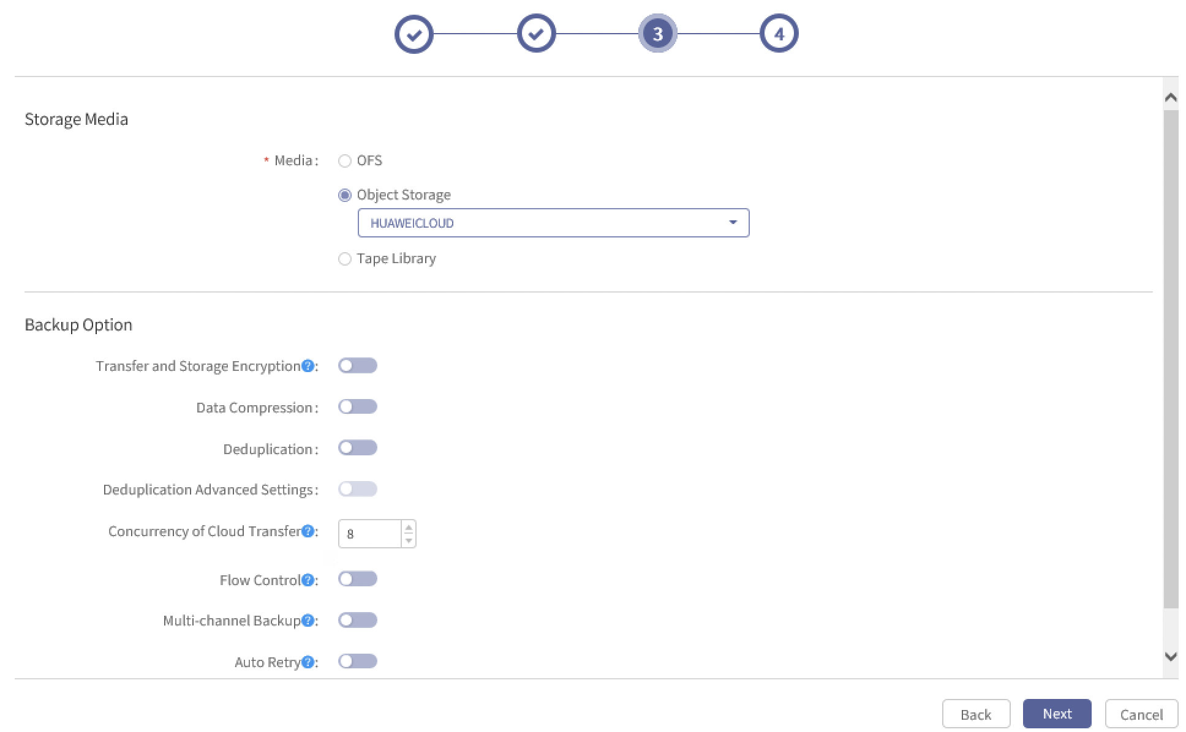

- Click Next to enter Job Name and Remarks page.
  - Job Name: Required. It shall be comprised of Chinese, uppercase and lowercase letters, numbers, and "-", "_", ".", "@", with 3~256 characters, not repeated globally.
  - Job Remarks: Optional. Type is not limited. The length shall be within 50 characters. If the length exceeds 50 characters, the extra characters cannot be displayed.
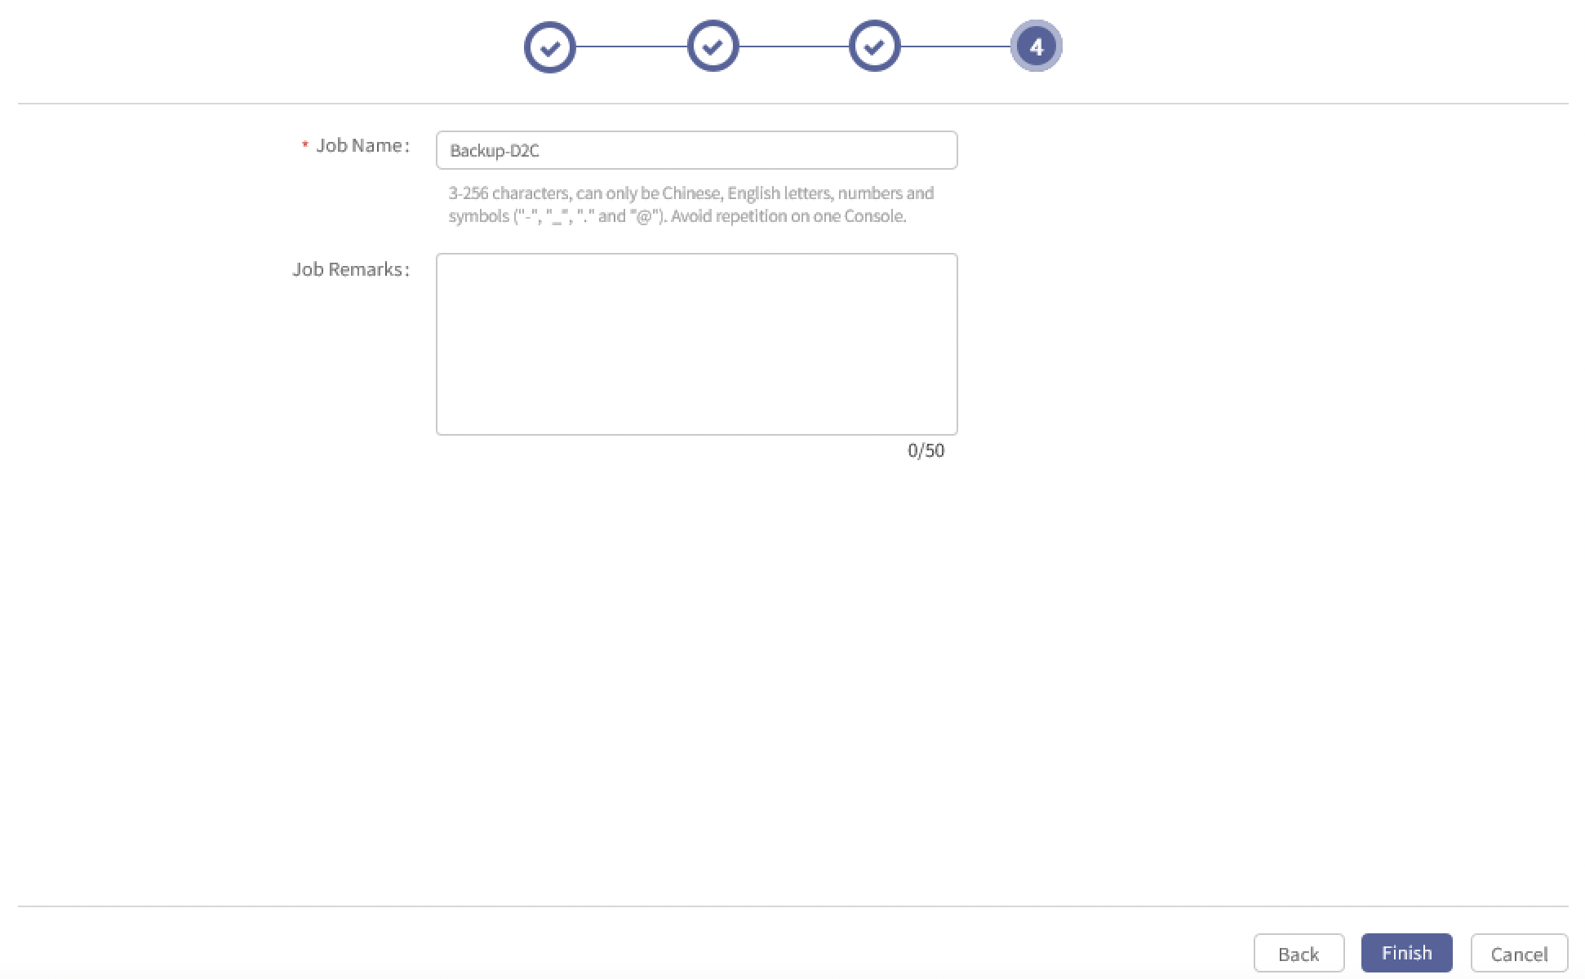

- Enter Name, Remarks and click Finish.
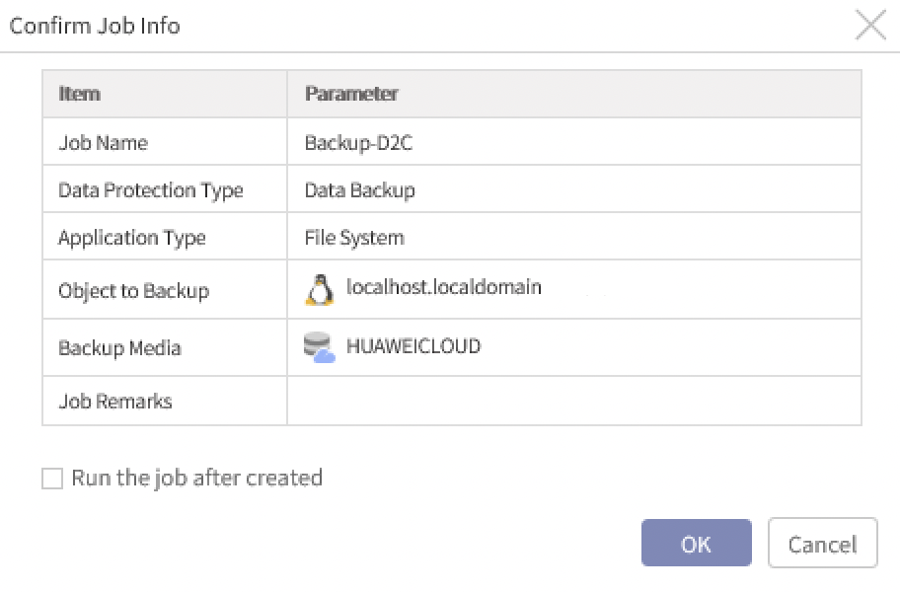

- Click OK and the job is created. If Run the job after created is ticked, the job will be executed immediately after OK is clicked.
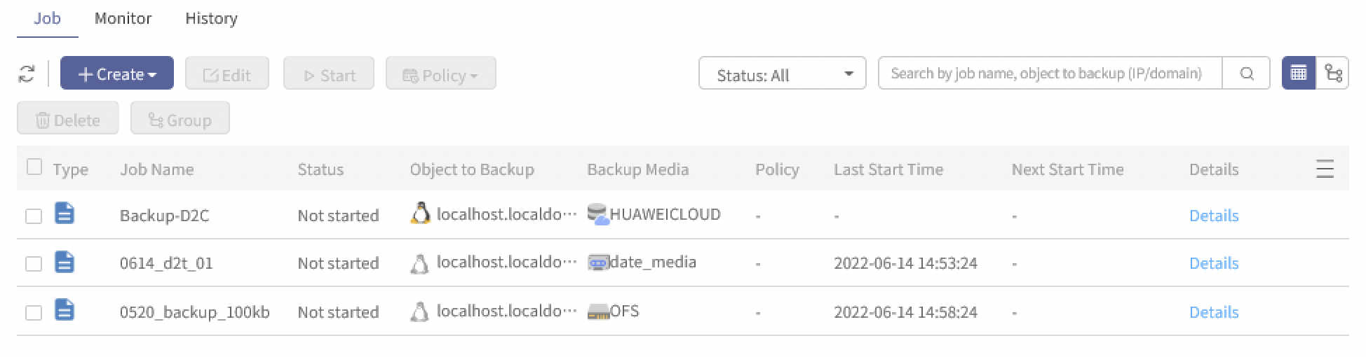

- To view more information, click Details and the information such as data source, policy and options enabled can be viewed.
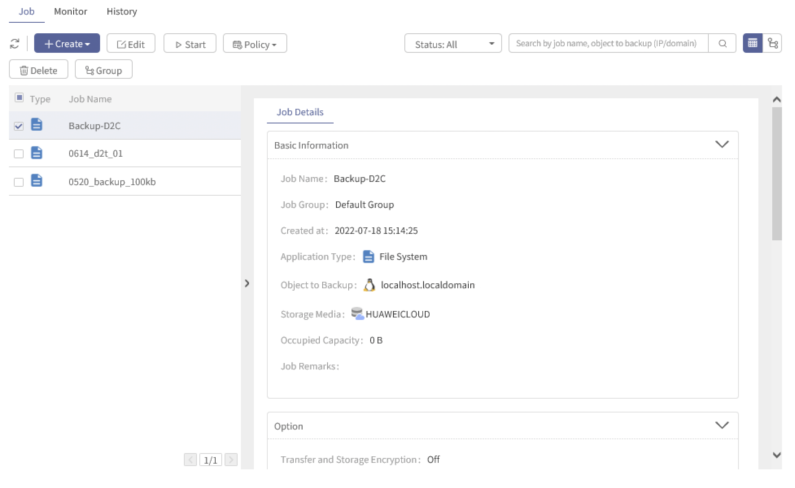

- Click Details in Monitor or History page and the execution information and execution output can be viewed.
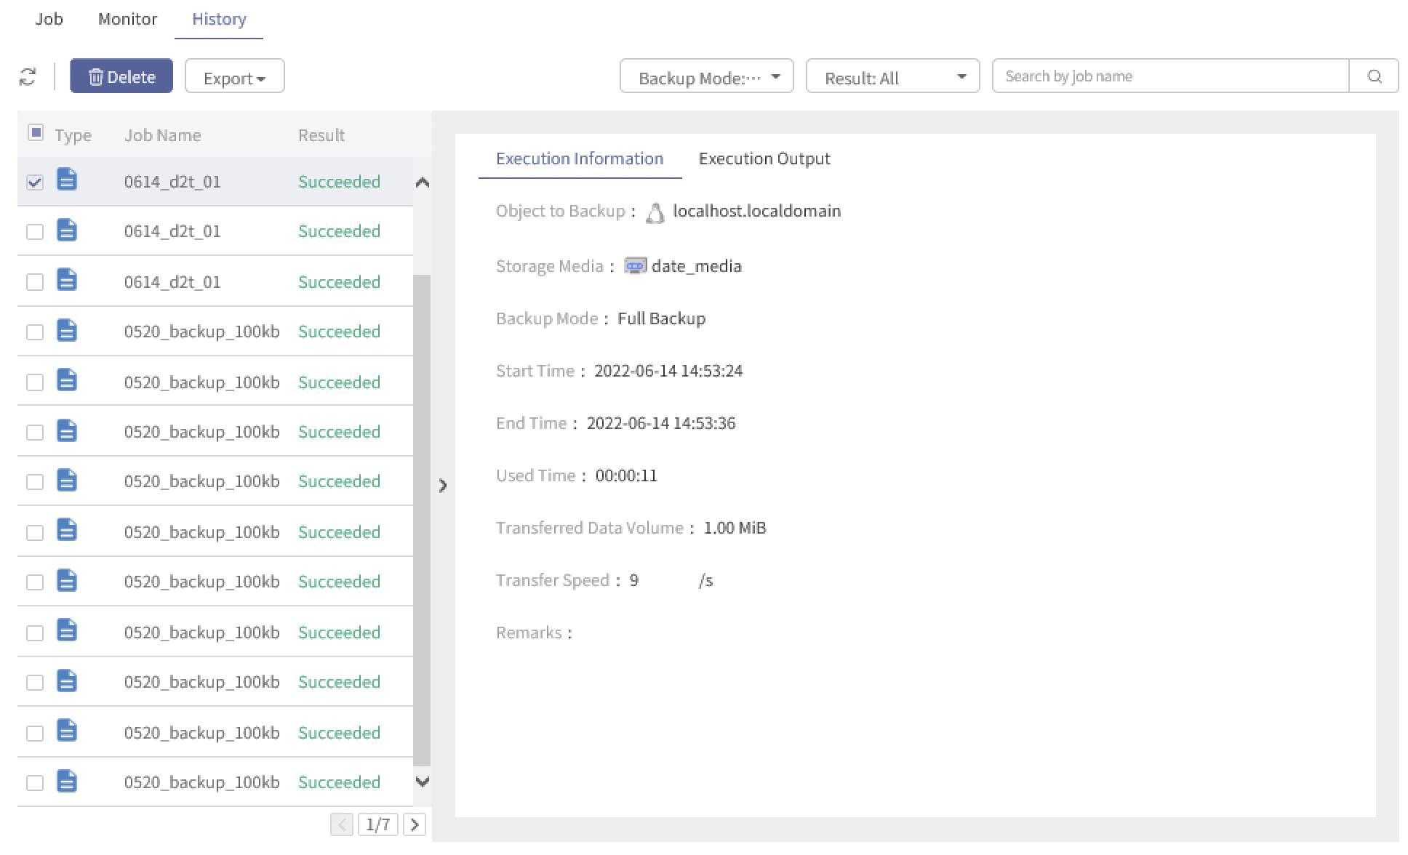

- To configure job plan, see AISHU AnyBackup Family 7 Best Practices for File System Backup and Recovery.
    - Starting Cloud Backup Jobs
- Select the job to be started and click Start. Select the backup mode and click Start.
- If the resource is enough, start a full backup immediately after the cloud backup job is created.
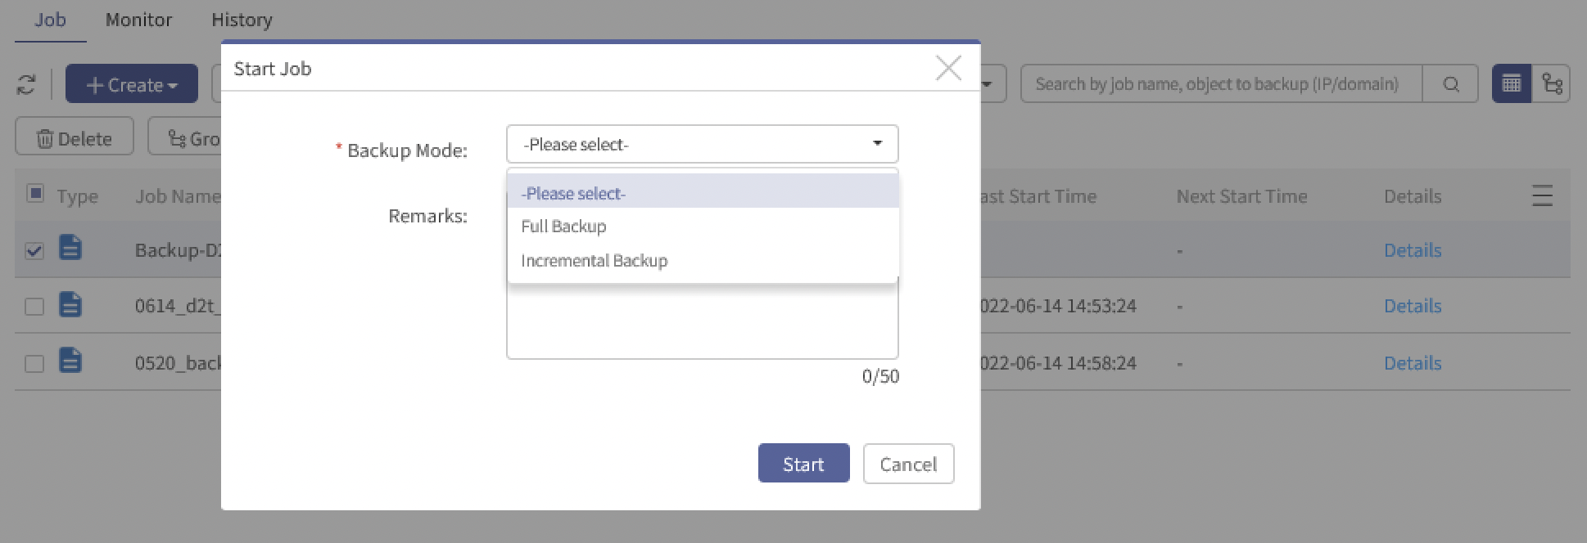

- After the job is started, the executing job can be viewed in the Monitor page.
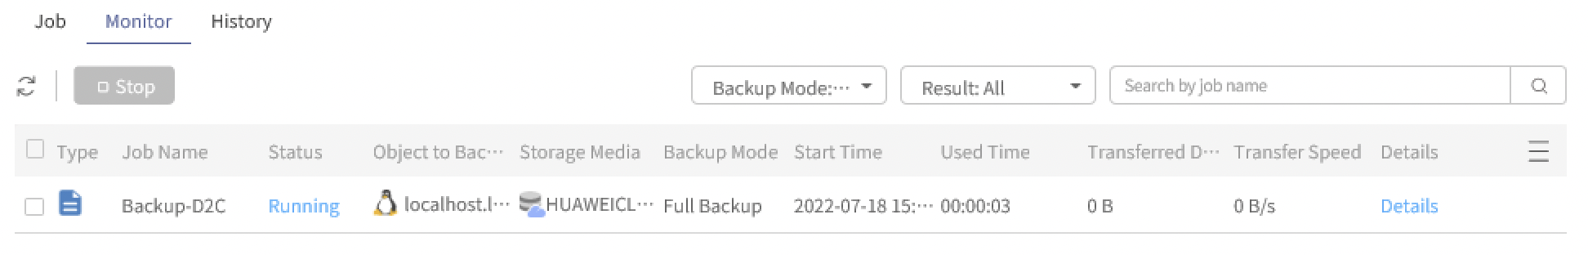

- Mind the following:
- Incremental backup will be converted to full backup if the first backup is incremental backup.
- If the first backup is incremental backup after the full backup fails, the incremental backup will be converted to full backup (regardless of any existing points in time of full backup).
- If the first backup is incremental backup after all copies are cleared by manually-started data cleanup, the incremental backup will be converted to full backup.
- When starting the job, data transfer mode depends on the configuration of the cloud storage, that is, if the cloud storage is in Server Mode, the backup data will be transited via server end. If the cloud storage is in Client Mode, the data will be directly transferred from client to cloud storage to client.
- If using Client Mode and cloud storages with SSL authentication enabled for backup, only parts of Redhat and CentOS are supported. For detailed compatibility, see AISHU AnyBackup Family 7 Software Compatibility List and AISHU AnyBackup Family 7 Best Practices.
    - Editing Cloud Backup Jobs
- Select the job to be edited and click Edit. The procedures are same with those of creating cloud backup jobs.
- Mind the following:
- Jobs that are running cannot be edited.
- Items can be edited: Data Source, Cloud Transfer Concurrency, Multi-channel Backup, Auto Retry and Remarks can be edited.
- Items cannot be edited: Objects to be Protected, Client, Application Type, Backup Media, Transfer and Storage Encryption, Data Compression and Job Name cannot be edited.
- Best Practices for Cloud Recovery

Best Practices for Cloud Recovery
This documentation takes file backup as an example. For other applications, see Best Practices. For example, if you want to perform Oracle backup, see AISHU AnyBackup Family 7 Best Practices for Oracle Backup and Recovery.
    - Creating Cloud Recovery Jobs
- Log into the console as an operator and click Backup and Recovery > Data Recovery > Recover Backup Data > Create. Select Object Storage in backup media and choose the cloud storage where the backup data is stored. Then select the job to be recovered. The job can be filtered by Type or Job Name.
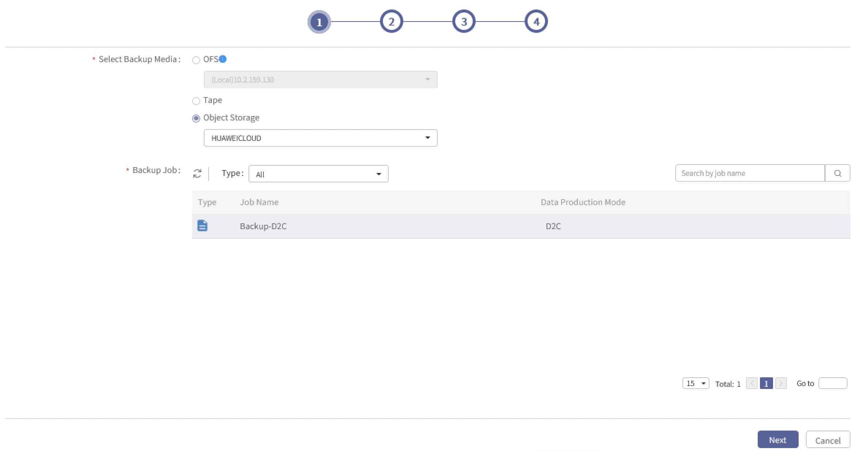

- Click Next and select the point in time and data to be recovered.
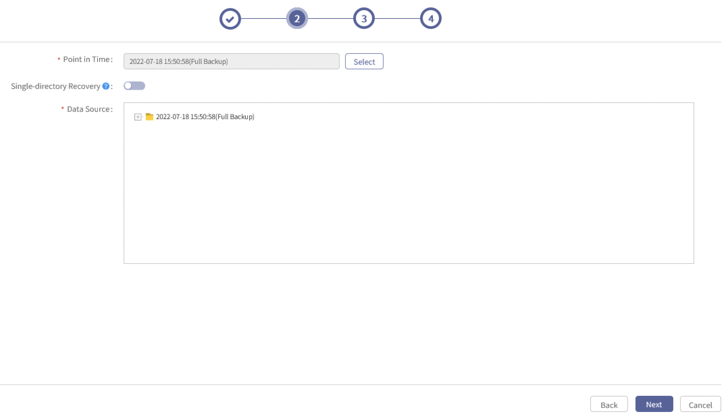

- Mind the following: Select the latest point in time if you want to recover to the latest status. Because the point in time selected is the data backed up that time, but not the latest.
- Click Next to select the recovery destination. Click Select to view the clients assigned to the current operator. You can select to recover to the original client (with prefix), or you can select to recover to a dissimilar machine. Select the client and the storage path and set the recovery options.
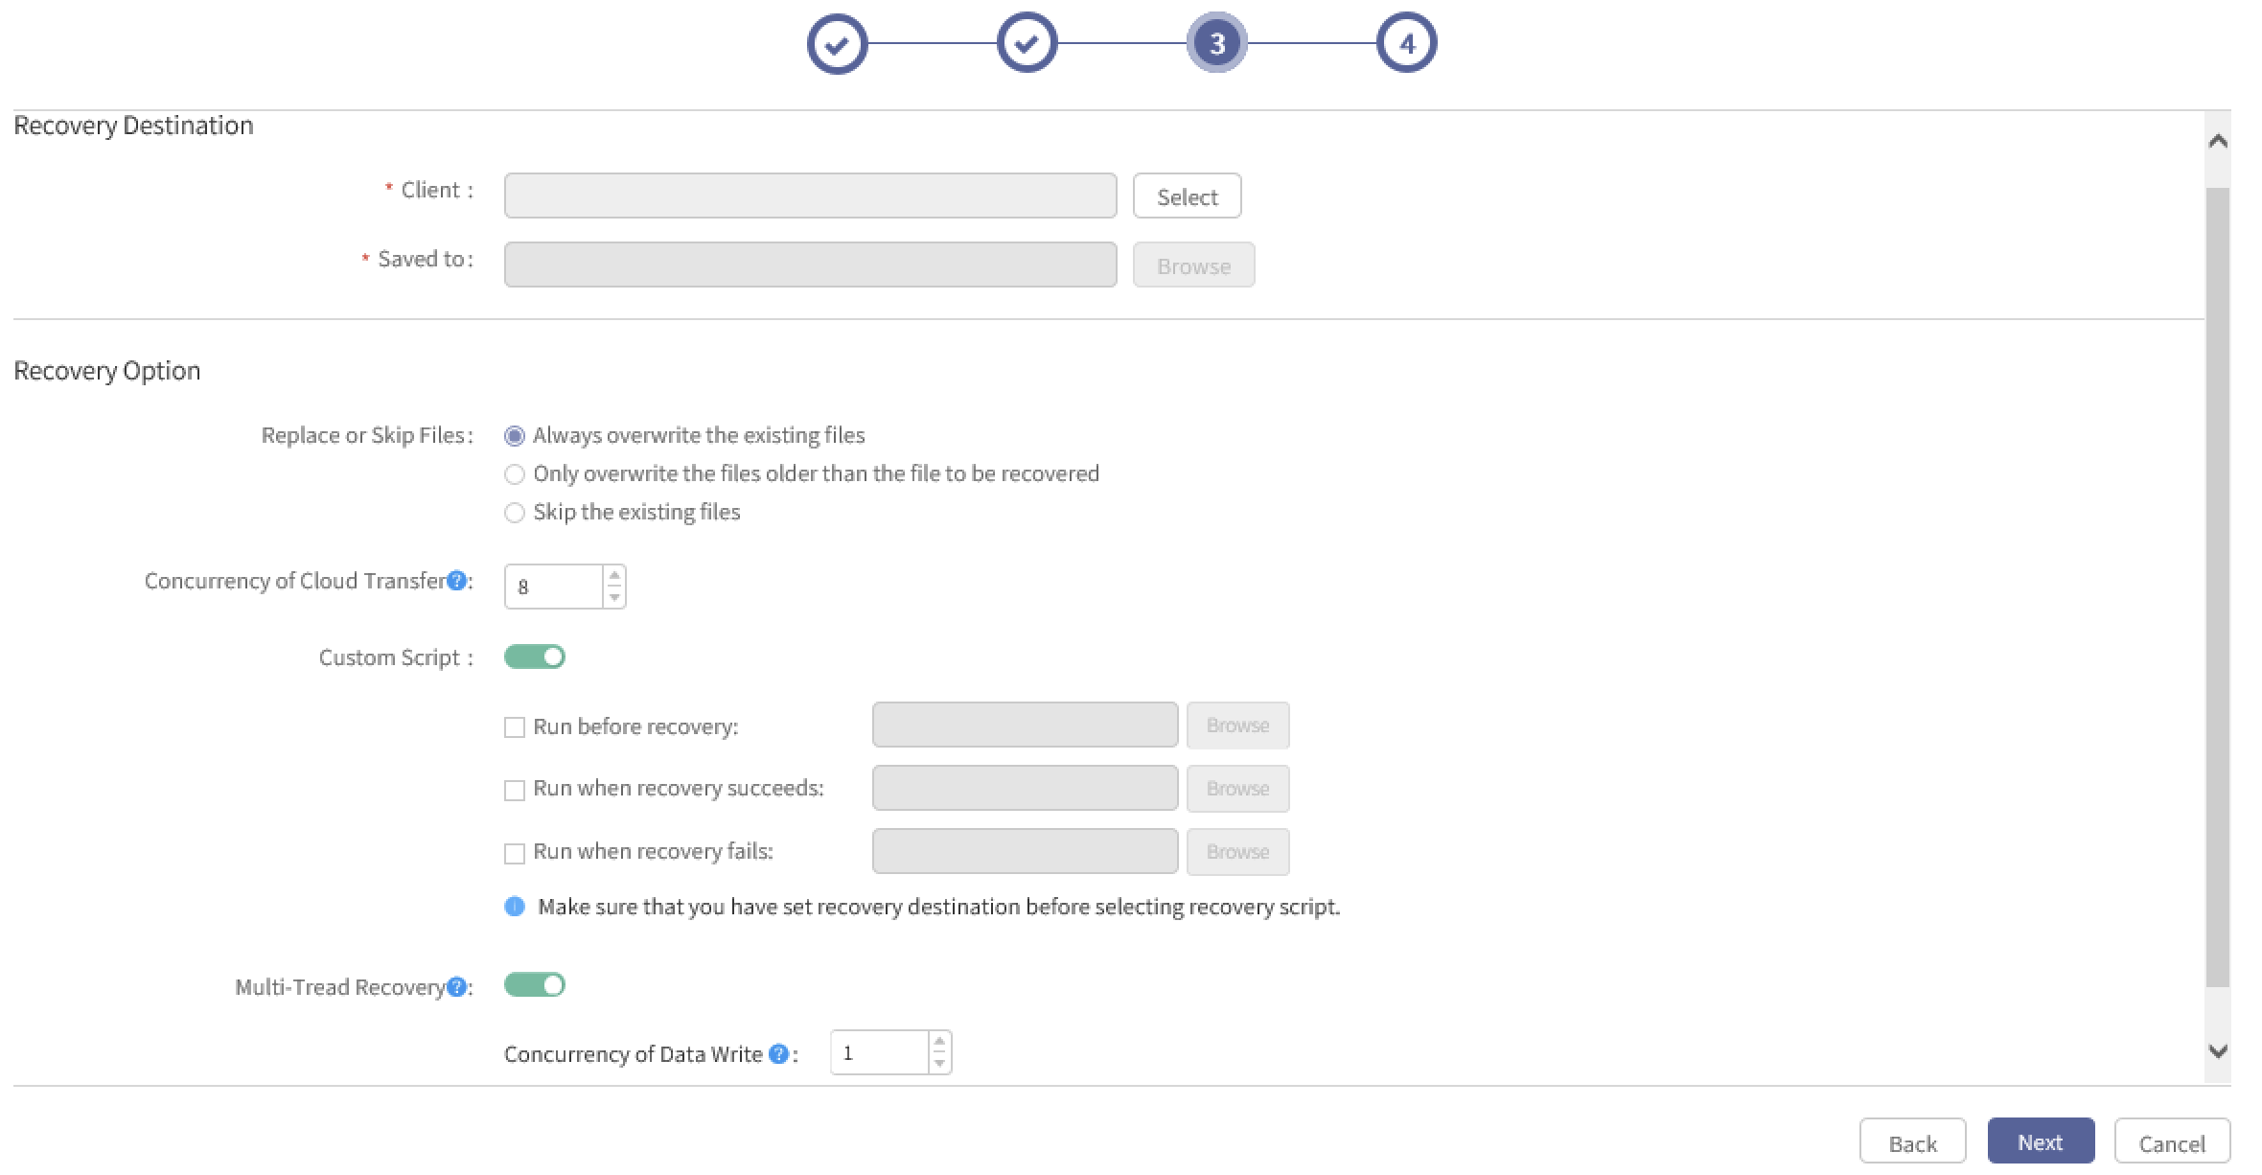

  - Recovery Option:
- Replace or Skip File: The default option is Replace the existing files, and other options can be chosen.
- Cloud Transfer Concurrency: 8 threads by default, can be configured from 1 to 64. Recovery speed can be enhanced by adding the number of threads, but more resources such as memory and CPU will be consumed.
- Custom Script: Custom script can be executed in different phases following the settings.
- Multi-Thread Recovery: Disabled by default. If it is enabled, the default concurrency is 1, can be set from 1 to 50. Recovery speed can be enhanced by adding the number of concurrency, but more resources such as memory and CPU will be consumed.
- Click Next to enter Job Name and Remarks.
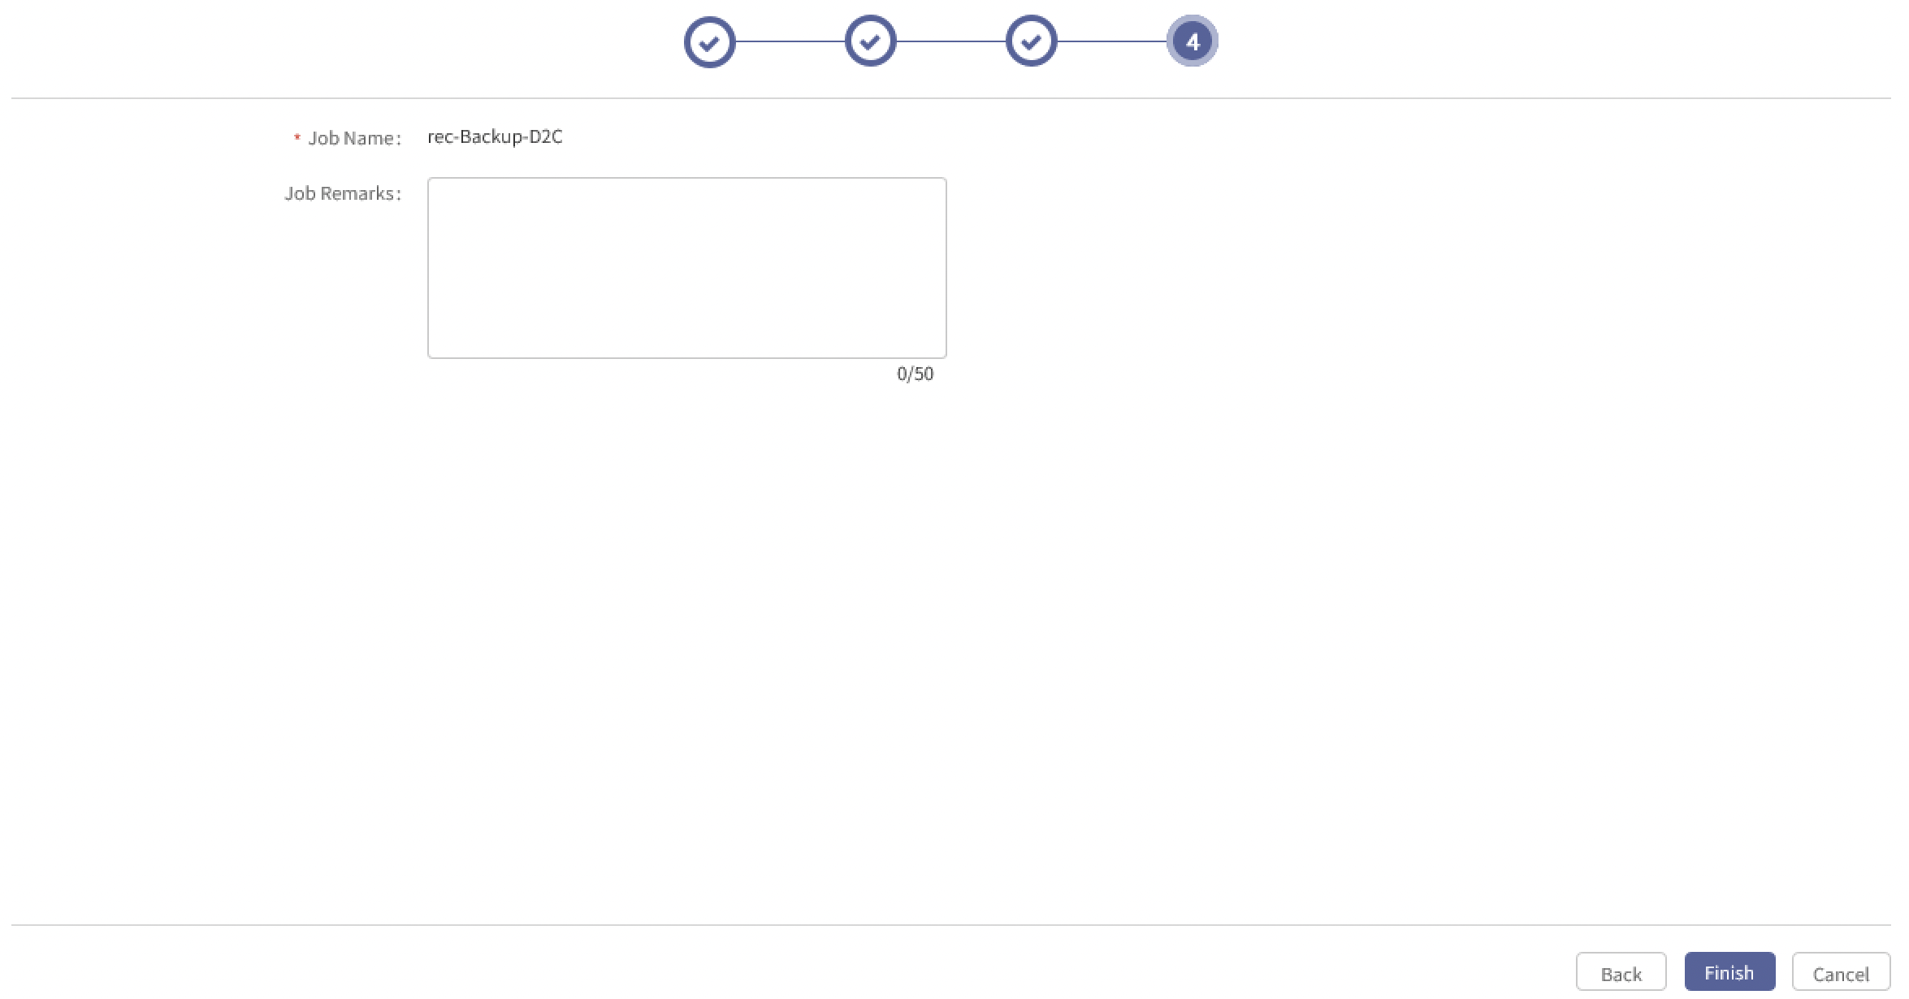

- Mind the following:
- The recovery job cannot be entered by yourself. The format is rec-[backup job name]. If the name repeats, a number will be added at the end of the name, for example, rec-task01 (1), rec-task01 (2) and rec-task01 (3). Enter YES and click OK to finish creating the recovery job. If you don’t want to recover, click Cancel.
- If the backup job has been deleted, the naming rule is rec-creation time-[backup job name].
- If the same file is recovered to the same path in two jobs at the same time, data loss will be caused. It is recommended that you recover to two different paths.
- Click Finish and the confirmation window will pop up.
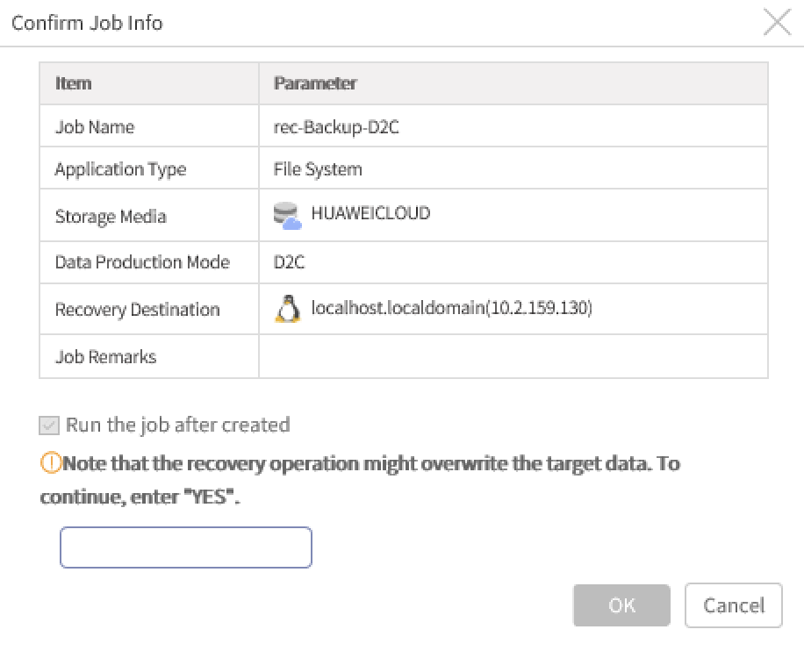

- Click OK and the recovery job is created and will be executed immediately.
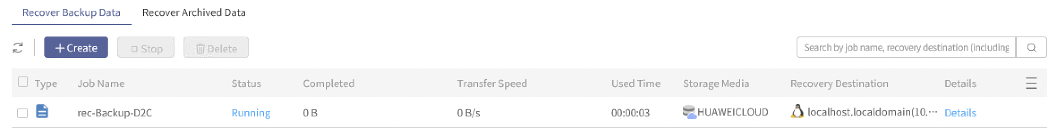

- Click Details and you can see the job details, execution information and execution output. Job details are displayed by default.
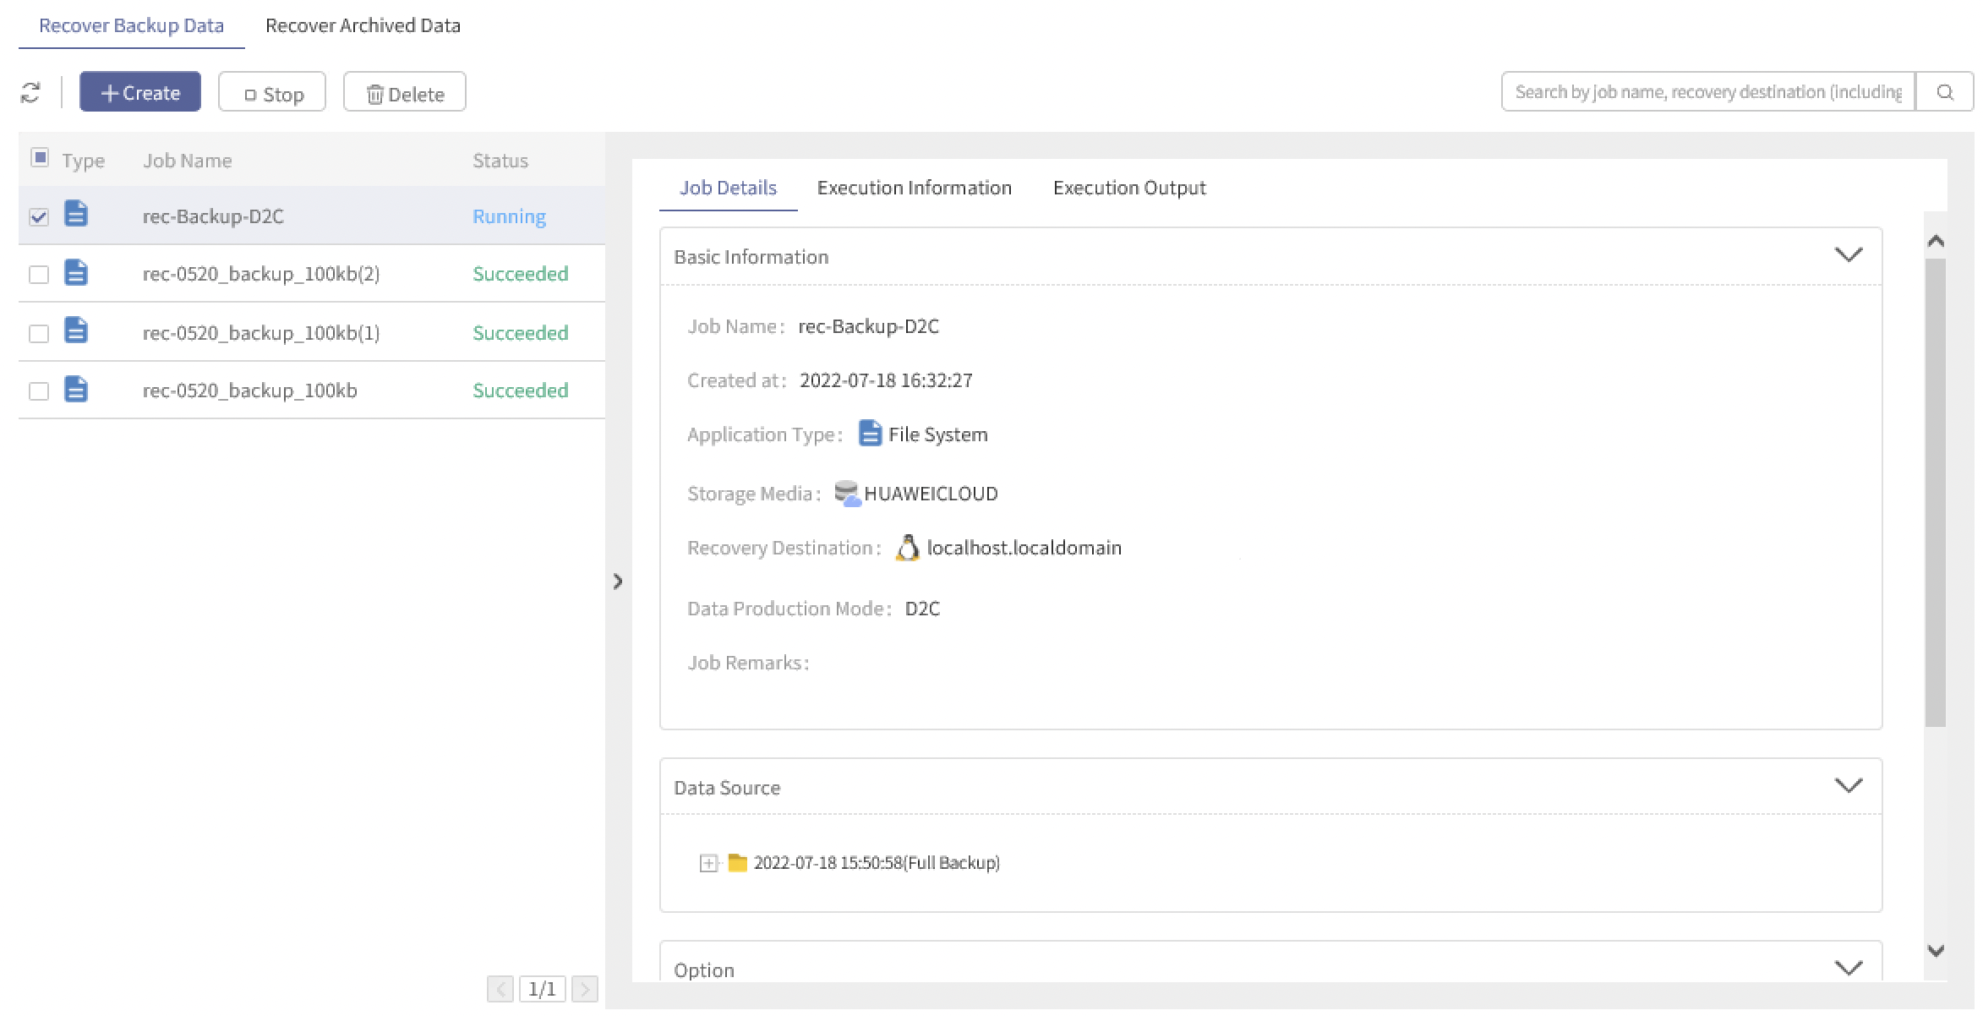

- View Execution Information.
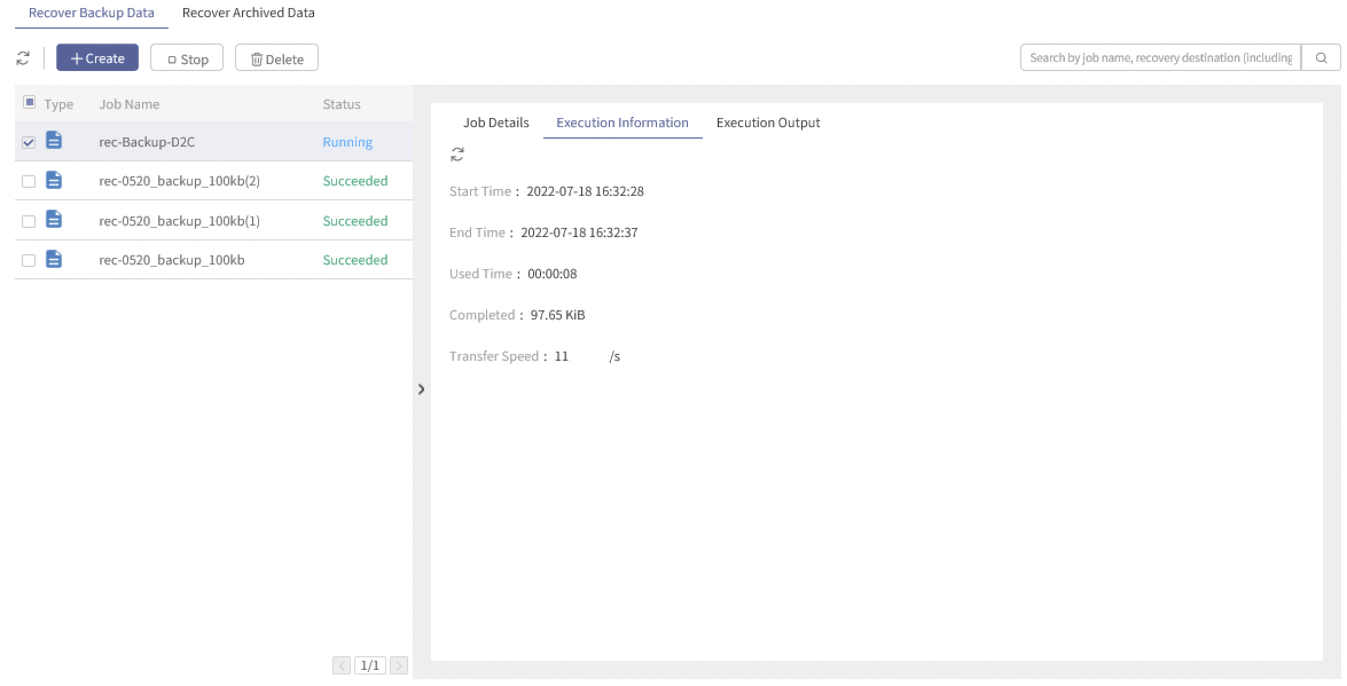

- Mind the following:
- Overwritten recovery can be performed when the client in recovery destination is online, and the file in destination is not being used.
- Files can be recovered to a dissimilar machine, but the file property recovered may be changed.
- Cross-platform recovery is not supported, for example, from Windows to Linux.
- Recovery jobs can be automatically started only once after the job is created.
- After a recovery job is created, data transfer mode depends on the configuration of the current cloud storage, that is, if the cloud storage is in Server Mode when the job is being created, the recovery data will be transited via server end. If the cloud storage is in Client Mode, the data will be directly recovered from cloud storage to client.
- If using Client Mode and cloud storages with SSL authentication enabled for recovery, only parts of Redhat and CentOS are supported. For detailed compatibility, see AISHU AnyBackup Family 7 Software Compatibility List.
- Best Practices for Data Cleanup

Best Practices for Data Cleanup
- Log into the console as an operator and click Backup and Recovery > Data Cleanup. Click Create in Clean up Backup Data. Select object storage in storage media and choose the cloud storage where the job to be cleaned is stored. Click Select in Backup Job option to choose the backup job to be cleaned. The backup job can be filtered by Type or Job Name.
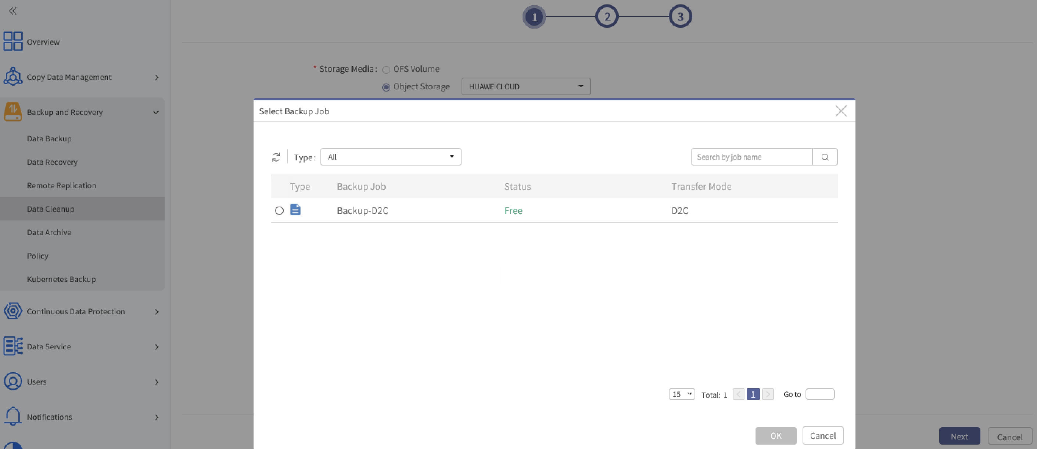

- If the data status is Occupied, the job cannot be cleaned up. Because the job is being backed up or recovered.
- Select the job and click OK. Click Next to select the copy to be cleaned up. It is defaulted to clean up all copies. You can choose to clean up a specified copy.
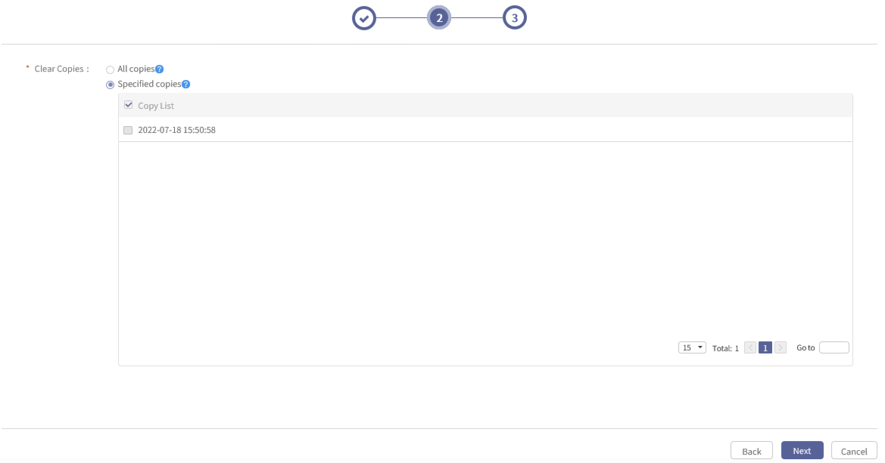

- Mind the following: In Clean All Copies, the copy of the latest point in time can be cleaned up. In Clean Specified Copies, the copy of the latest point in time cannot be cleaned up.
- Click Next to enter Job Name and Remarks page.
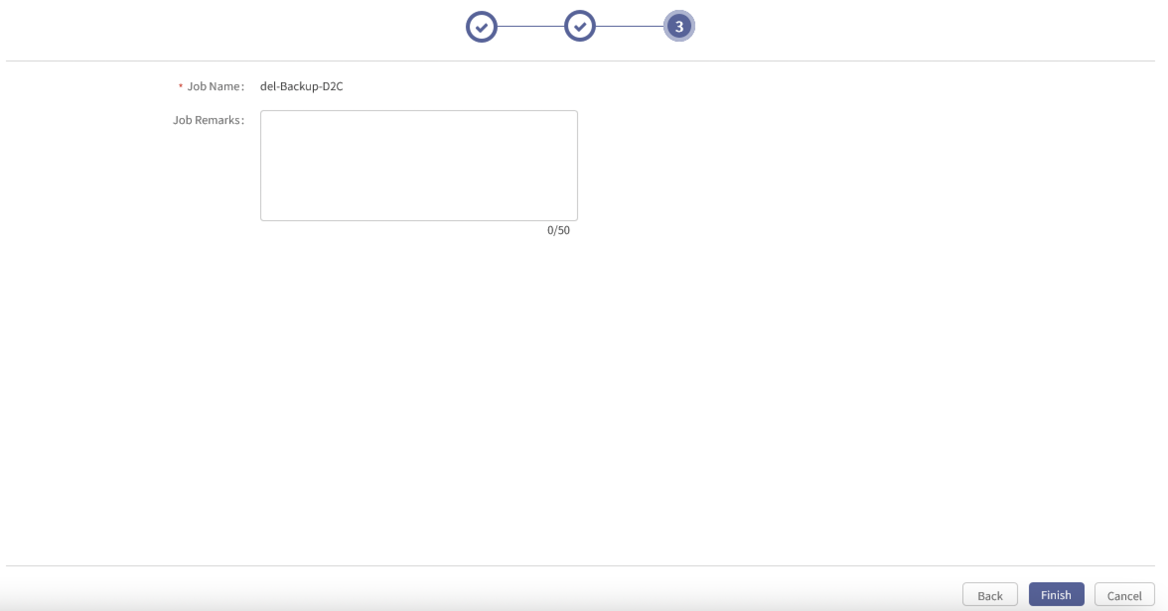

- Click Finish and the confirmation window will pop up.
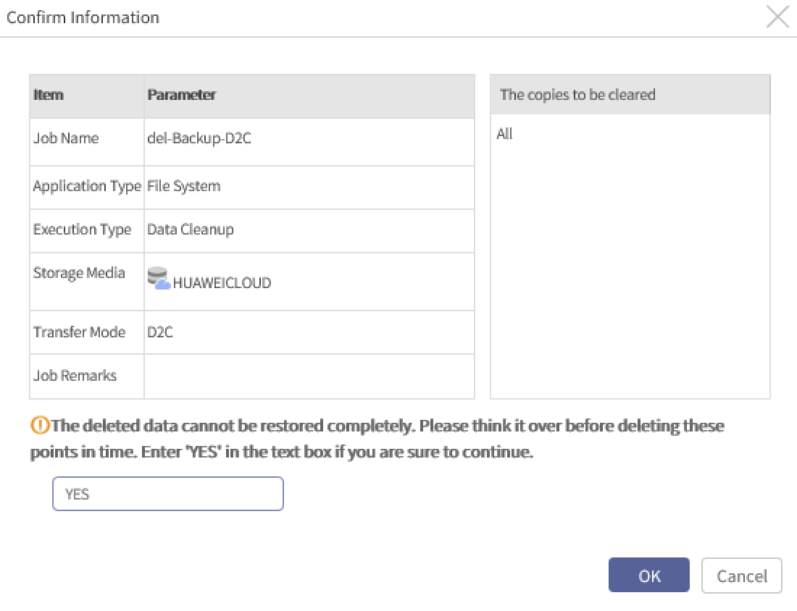

- Enter YES. It is case-sensitive, YES must be capital letters.
- After data cleanup is completed, check whether the cloud storage space is changed.
- Mind the following: Data cleanup will be conducted in the background after the job is created, which may take some time before the storage space is released.
- Best Practices for Cloud Disaster Recovery

Recovering via Self-backup Package
Introduction
AnyBackup console is deployed in the local data center and the data is backed up to the cloud via D2C. When the console breaks down, you can rebuild a console with the self-backup package of the original console and recover the data from the cloud to the target client.
    - Solution
- Job data shall be got from database during recovery, thus self-backup package is needed to recover job data on console.
- The console can only be recovered to the original machine using self-backup package. Thus data on cloud can only be recovered via the original console.
    - How to Recover
- To recover console via self-backup package, see AISHU AnyBackup Family 7 Best Practices for Metadata Backup and Recovery.
- To create a recovery job so that the data on cloud can be recovered to the target client, see Chapter 5.1. Jobs with encryption enabled cannot be recovered after reconstruction.
- About Configurations

About Configurations
For file systems with large amount of data (more than 500 GiB), it is recommended to set a long interval for backup jobs because the next backup will not be started if the backup is still running.
When setting policies, do not set a complete set of incremental backups after an initial full backup. A minimum of one full backup shall be performed every month to ensure data security.
- FAQs

Backup
- Q1: A node in the cluster is powered off within 30 minutes and the client is online. But the backup job fails to be started and the client displays Offline.
Cause:
After the node is powered off, an available node of ClusterService will be requested when starting a backup job, but the update time of the available node list determined by Cluster is uncertain, and the client will be considered offline.
Solution:
After the console is abnormal, the client will connect to other normal nodes in 5-30 minutes. The client can be normally used after it is reconnected. During this time, the status of the client is Online.
- Q2: A job with deduplication enabled is running, but the data amount transferred is 0.
Cause:
There is a cleanup job using the same fingerprint in the background.
Solution:
Wait until the cleanup job finishes and the D2C job will be executed.
- Q3: Backup job fails and an error “Cannot connect to the specified server. Cause: Network error, object storage is unavailable or host name is incorrect.” occurs.
Cause:
When the network between Client and Object Storage is abnormal or when the bandwidth is insufficient, the connection with Object Storage will timeout and the job may fail.
Solution:
1. Recover the network.
2. Edit the job. Reduce the cloud transfer concurrency.

Recovery
- Q1: After the console is reconstructed, self-recovery is not performed using self-recovery package. When executing recovery, there is data when querying recovery jobs, but not displayed. Or when D2C job is created, there is data when recovering the job, but the list is empty.
Cause:
If the self-recovery package is not imported to recover the original console data (backup job data mainly) when reconstructing the same console (server, IP, user and cloud storage resources are same as before), all data on cloud storage can be queried in the background during recovery. But data displayed in the foreground is re-filtered, and the original backup data does not exist, thus it cannot be displayed. This causes the data inconsistency in the background and foreground.
If there are 5 jobs on the new console, these jobs may not be displayed on the first page, so that the first page is empty during recovery.
Solution:
Clean up data on cloud manually after reconstruction and before backup.

Others
- Q1: Error “Failed to get the bucket list. Cause: Network error, object storage is unavailable, access ID or password is incorrect, or the cloud server cannot be synchronized with the local media server” occurs when adding cloud storage.
Cause:
- The network between backup server and cloud storage is abnormal (DNS is not configured, or intranet-extranet whitelist is not applied for).
- The system time or timezone of backup server or client is 15 minutes earlier or later than that of the cloud storage server.
- Server host, access ID or password is incorrect.
- Check whether it is a standard bucket. Check whether the domain name is correct and whether read and write permissions are granted.
Solution:
- Configure the network between backup server or client and cloud storage. Make sure that the host of cloud storage can be pinged by backup server.
- Edit the system time using command date –s to make the time and timezone of backup server and cloud storage the same.
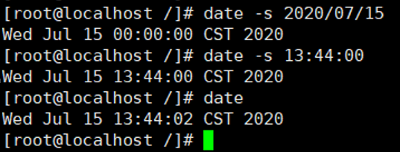

Use command timedatectl set-timezone to edit the timezone.
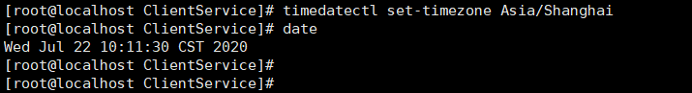

- Enter correct service host, access ID and password.
- Edit the bucket permissions.
- Q2: When adding cloud storages, “An error occurred when the service ECSSService interface GetBucketList was called. Cause: unexpected exception”.
Cause:
The network is poor and the interface call timed out.
Solution:
Try again or wait until the network is normal.
- Q3: When adding cloud storages using https protocol, an error “Request failed, Cause: Problem with the SSL CA cert(path?access rights?)” occurs.
Cause:
The certificate does not match when getting the SSL certificate of the cloud storage.
Solution:
Run command update-ca-trust on console before adding the cloud storage.
- Q4: When adding or editing cloud storage, an error “Failed to get the data center node where the bucket resides. Cause: Network error or object storage is unavailable” occurs when you manually enter the bucket name.
Cause:
Take HUAWEI CLOUD OBS which has multiple regions as an example. If certain bucket (for example, bucket 111) does not exist on the region where the bucket resides, but it exists on other regions, the buckets of other regions will be found when adding buckets, but the user has no access permission to this region, thus the adding fails, indicating that the data center node where the bucket resides cannot be got.
Solution:
Use the bucket with access permissions.



