**Video cloud integrated management system**

**Web side Usage Description 3.6.0**

JOYWARE

Catalogue

1 Login 1

2 Configuring the Center 1

2.1 Resource management 1

2.1.1 Device Management 1

2.1.2 Service Management 4

2.1.3 Administrative tree management 5

2.2 Media Management 7

2.2.1 Cascading Management 7

2.2.2 Storage Configuration 11

2.2.3 Live broadcast management 13

2.2.4 Configuring the Network Domain 14

2.3 System Configuration 15

2.3.1 Rights Management 15

2.3.2 Configuring Platform Information 18

3 Scenario Application 18

3.1 Video Surveillance 18

3.1.1 Real-time Video 18

3.1.2 Video Playback 19

4 Alarm operation and maintenance 21

4.1 Operation and Maintenance Plan 21

4.1.1 Configuring a Task Plan 21

4.1.2 Task Status 22

4.1.3 Channel Online Rate 23

4.1.4 Video integrity 24

# Login

Enter http://ip: port /jwentry/login to go to the login page, and enter the user name and password, as shown in Figure1-1. 

Figure 1-1

# Configuring the Center

## Resource management

### Device Management

#### Device Type Management

On the Device type management page, the supported device types are displayed,asshowninFigure 2-1.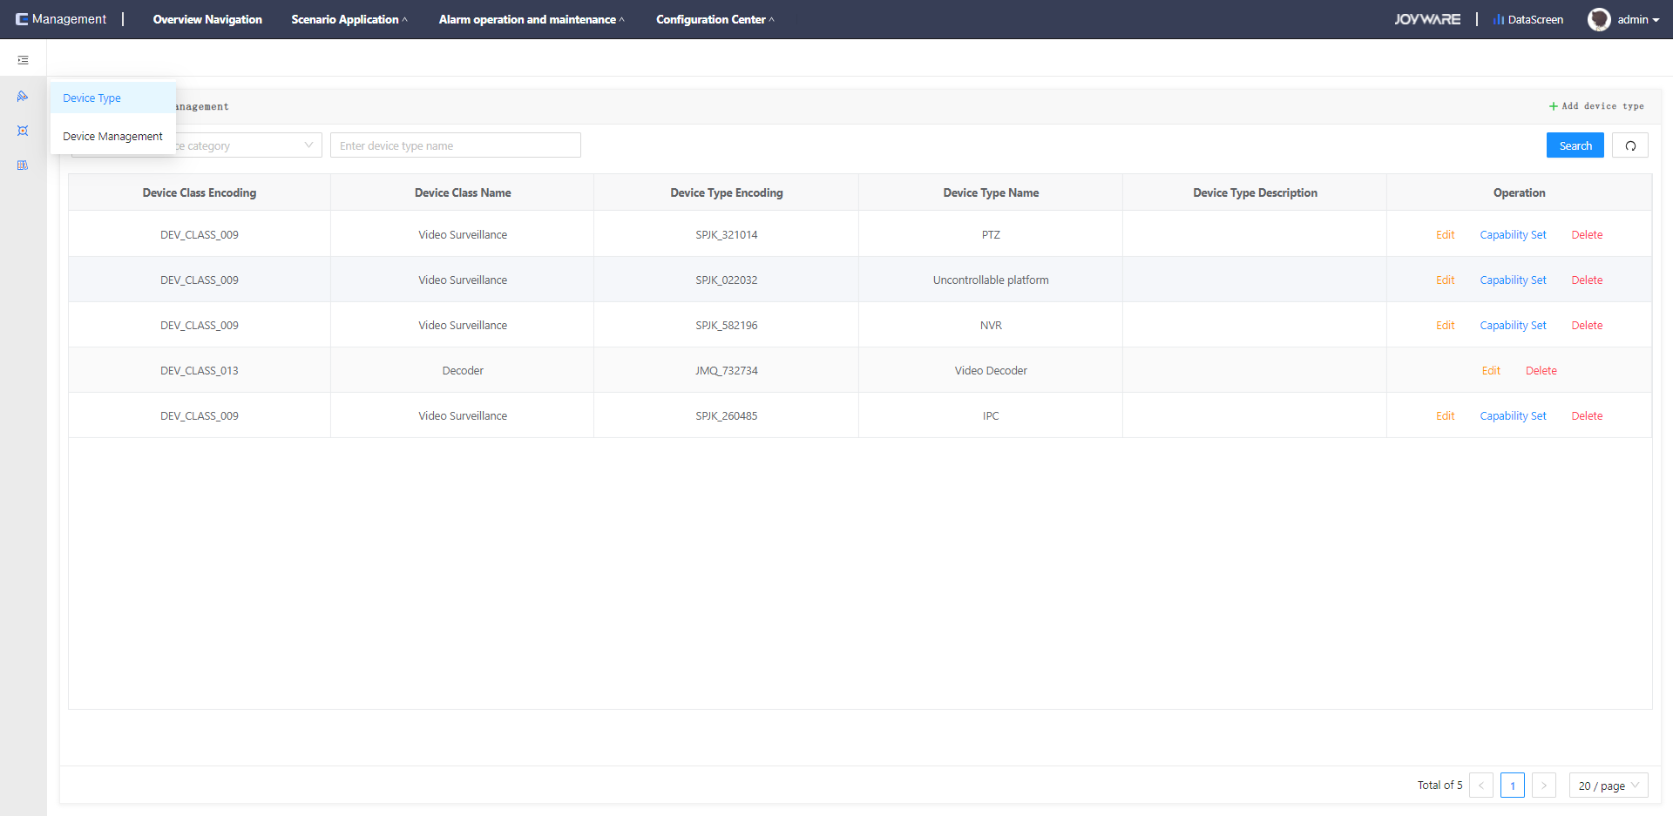

Figure 2-1

#### Device Management

To add a device tree, right-click in the node tree area and add a root node or a sub-group as required, as shown in Figure 2-2

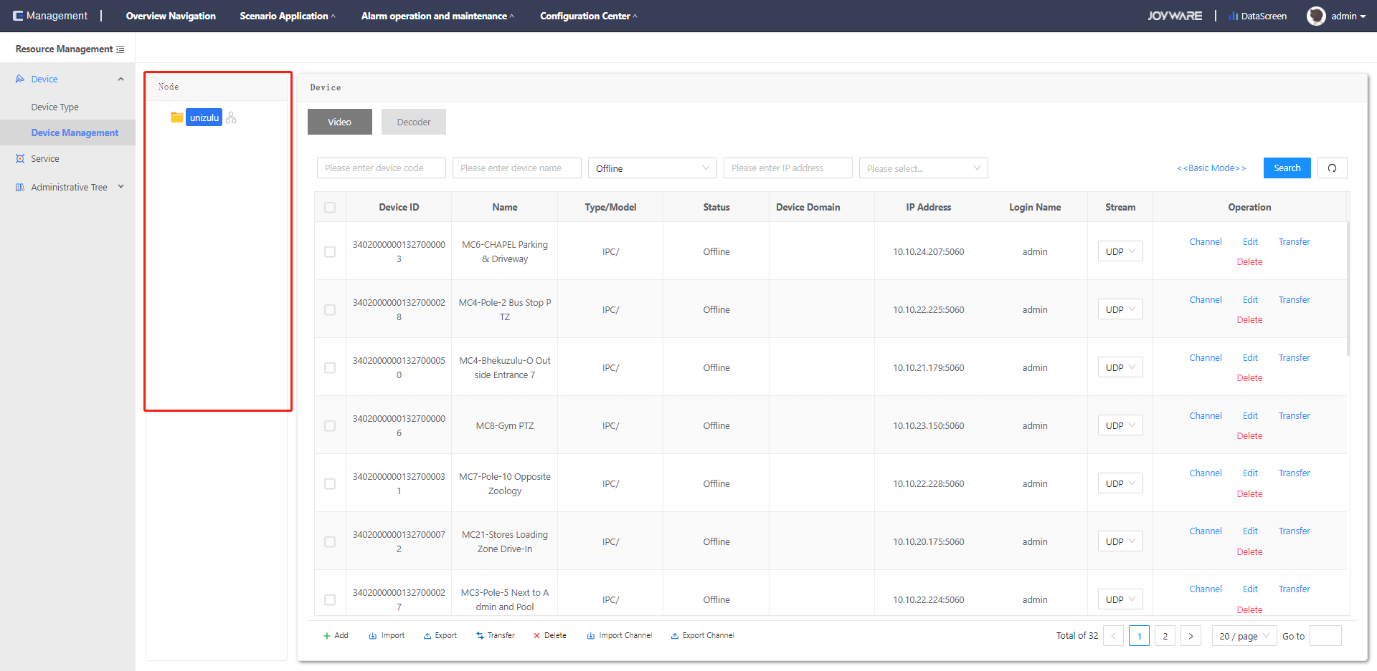

Figure 2-2

To add a device, select the node, select a video device, click Add, and fill in the information about the device to be added. You can manually video the device, and you can modify the added device information by clicking the Edit button. You can import and export devices and channels in batches, and delete one or more added devices in batches. You can transfer the added devices to another node tree, as shown in Figure 2-3. Enter the device number, device name, online status, IP address, and device type to query the added devices.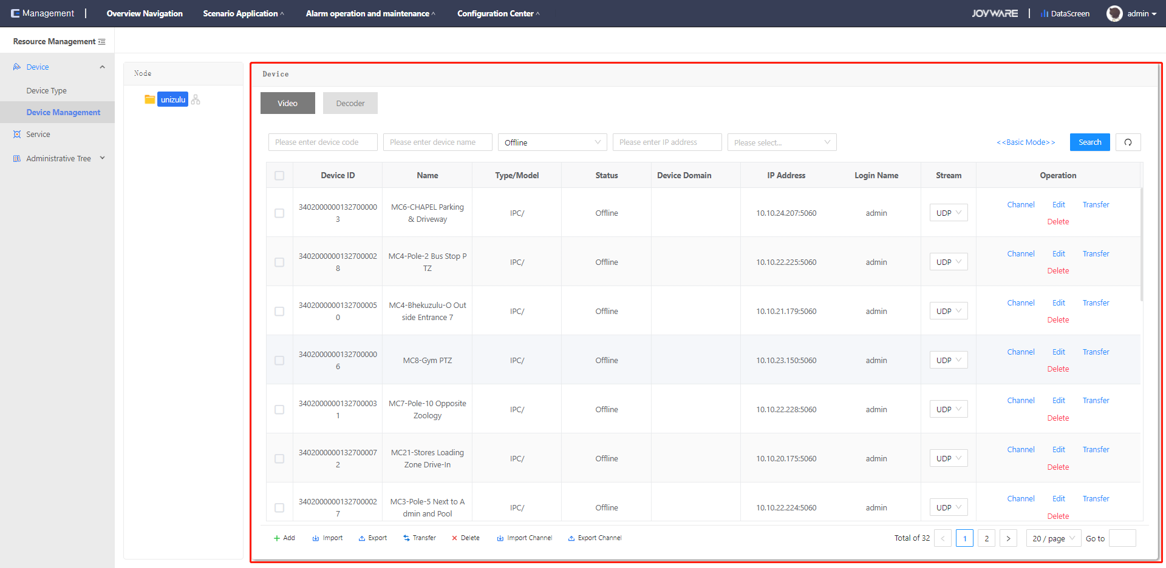

Figure 2-3

Select node, select decoder device, support adding decoder device, as shown in Figure 2-4:

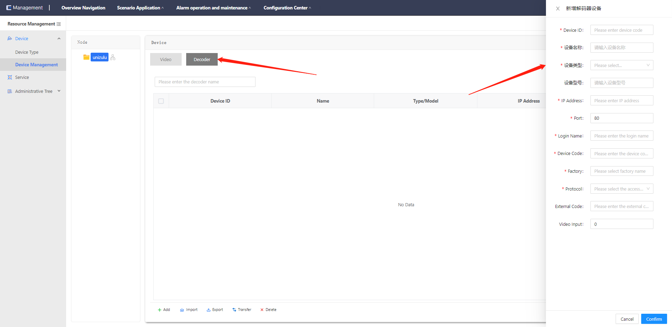

Figure 2-4

Importing devices in batches: Edit device information in the device import template, as shown in Figure 2-5. Device id, Device Name, Device Type, ip address, Port, Login name, Verification Code, and Access Protocol are mandatory



Figure 2-5

When the access device is a network camera or network hard disk recorder

Device Type is GB, Device id, Device Type, and Verification Code are assigned by the video cloud platform, and the GB configuration information of the network camera or network hard disk recorder can be set accordingly, as shown in Figure 2-6: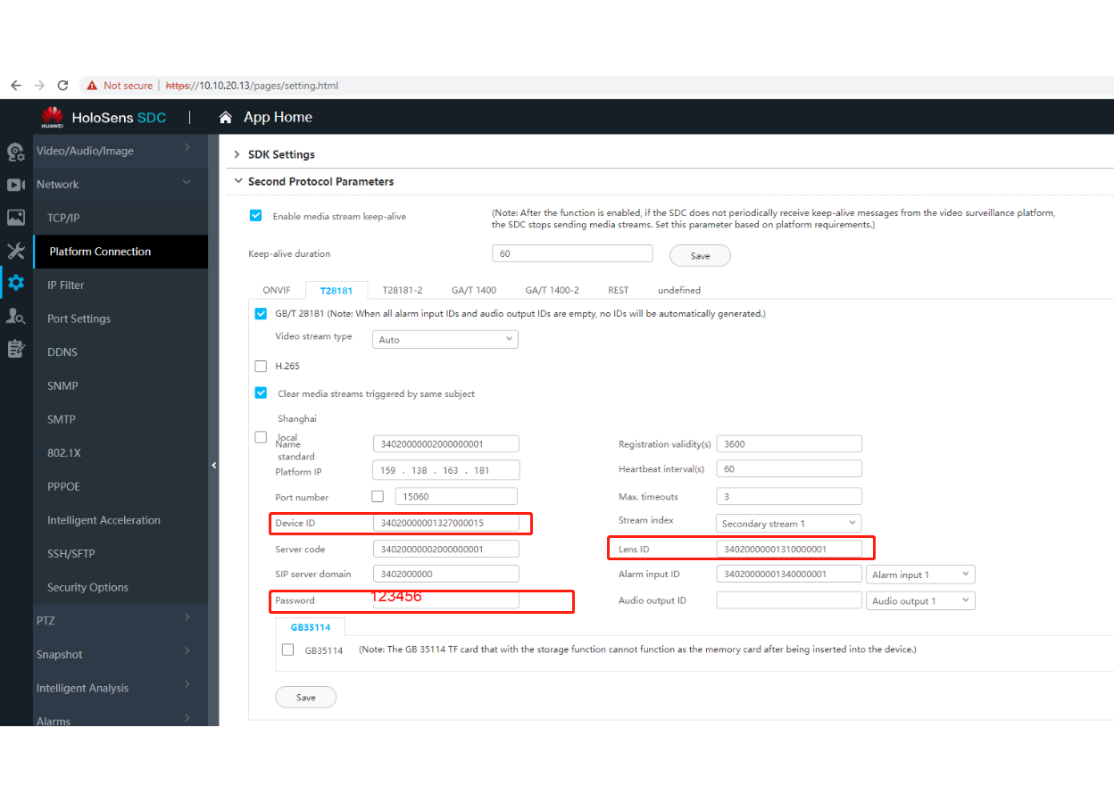

图2-6

The four parameters, Platform IP, Port Number, Server Code, and SIP Server domain, are the parameters of the video cloud platform and are fixed. Four parameters, Registration Validity Period, Heartbeat Period, Maximum Timeout Times, and Code Stream Index, are valid by default. Set Device Name, ip Address, Port, Login Name, and Verification Code based on site requirements.

Device Type is ONVIF, HIK, and DAHUA. Device id and Device Type are assigned by the video cloud platform. Other configurations can be modified based on the actual configuration of the network camera or network hard disk recorder.

### Service Management

The Configuration Center - Resource Management - Service Management page is displayed, and system service information is displayed, as shown in Figure 2-7.

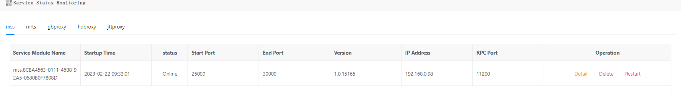

Figure 2-7

### Administrative tree management

#### Administrative Node

Resource directories are created based on actual usage requirements and corresponding video channels are assigned to corresponding directories for easy search and use.

The Administrative Node page is displayed, and you can create a directory, as shown in Figure 2-8

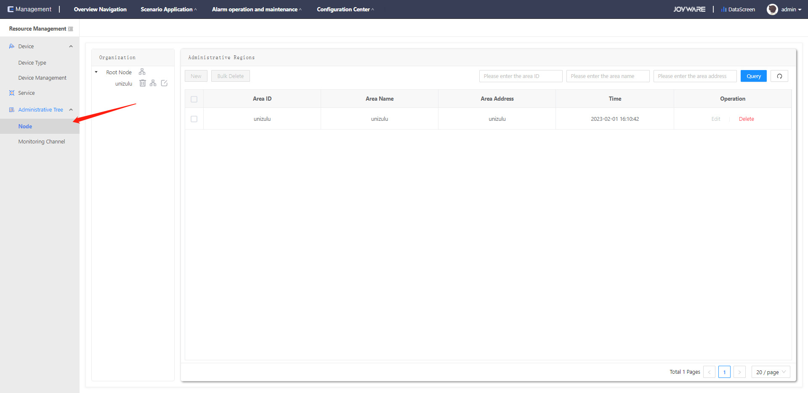

Figure 2-8

1. Single node root node button. The New Node page is displayed, and add the node name
2. Select a node directory and click Add. The Add Area button is displayed
3. Set the region ID, name, and address as required, and add a region. The region ID cannot be set repeatedly, as shown in Figure 2-9

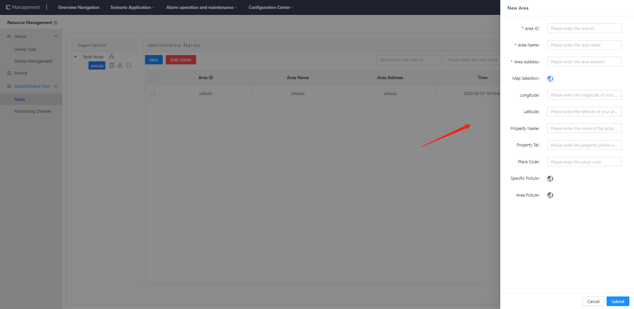

Figure 2-9

#### Monitoring Channels

Associate a video channel in the corresponding directory, as shown in Figure 2-10 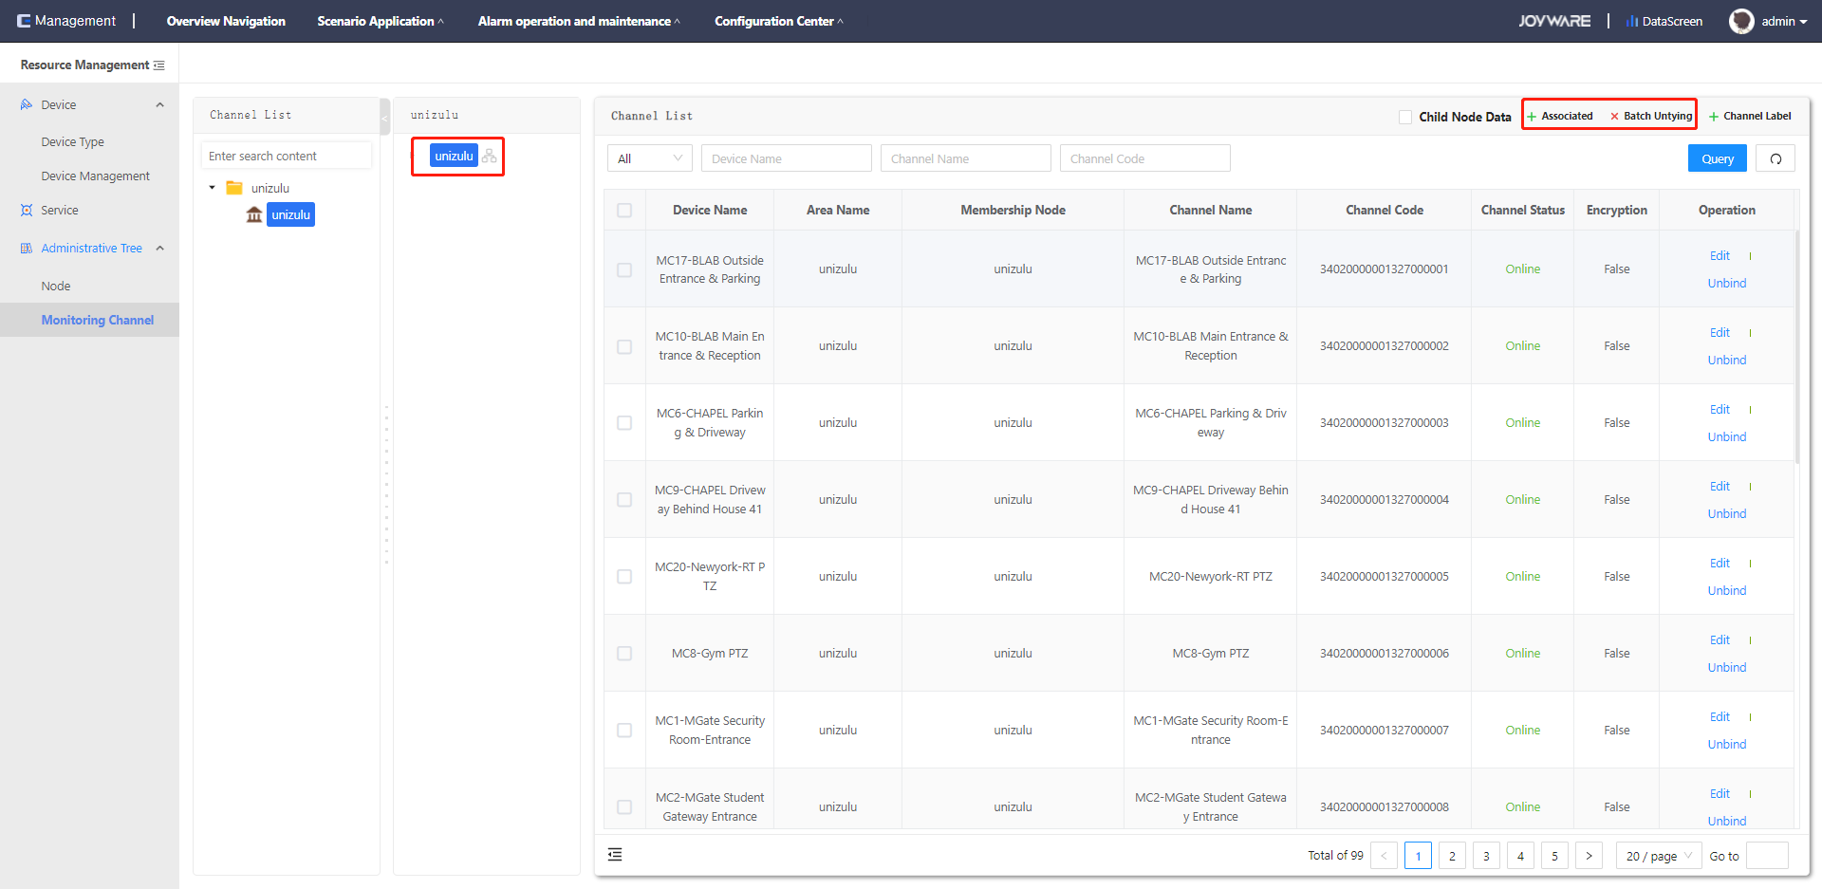

Figure 2-10

1. Click to select the directory that you want to associate the video channel with.
2. Click Associated Channel. The channel list window is displayed.
3. Select the video channel to be associated;
4. Click Batch Associate to associate video channels to a specified directory.

The video channel association is complete, as shown in Figure 2-11 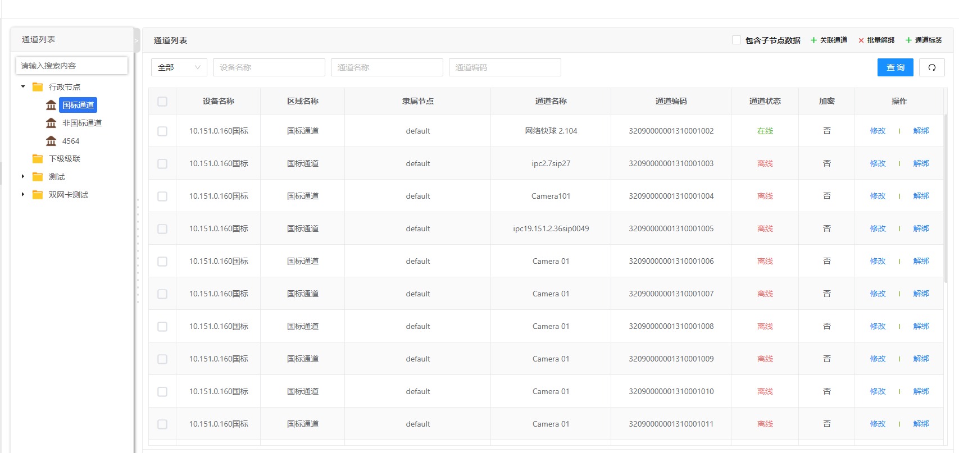

Figure 2-11

## Media Management

### Cascading Management

#### This level configuration

Configure and manage gateway information of this level, as shown in Figure 2-12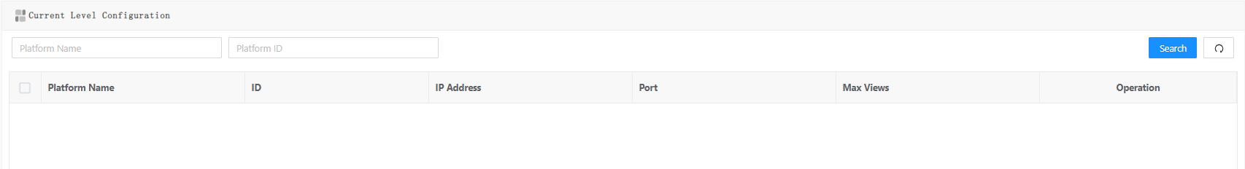

Figure 2-12

1. Click Add, and the information configuration page is displayed, as shown in Figure 2-13.

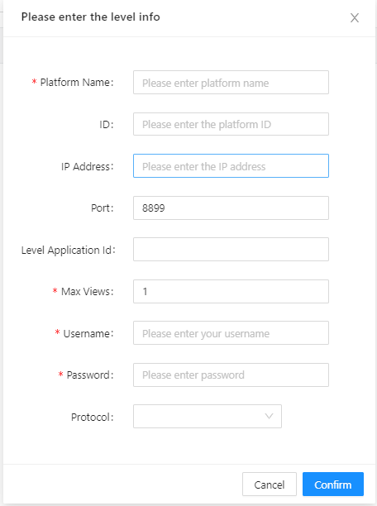

Figure 2-13

1. ID, IP, port, external IP, local application ID, user name, and password are used for video cloud platform analysis. The protocol is UDP by default. The registration period is 3600 seconds by default
2. You can modify or delete configurations of this level

#### Cascading Reception

Configure and manage lower-layer gateway information and view receiving channel information, as shown in Figure 2-14 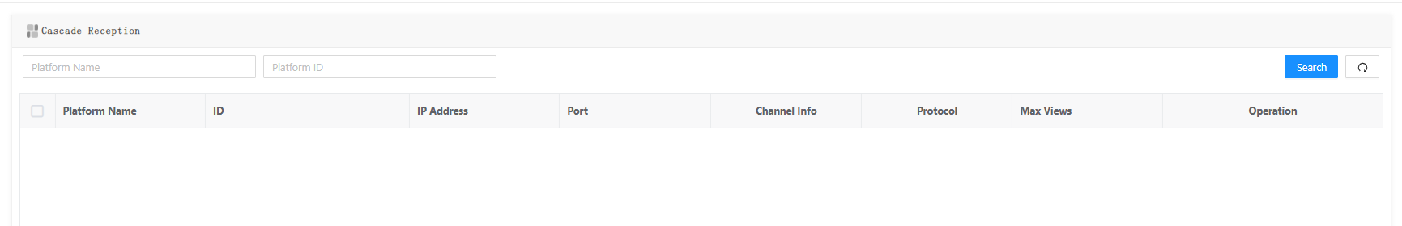

Figure 2-14

1. Click Add. The upper-layer platform information configuration page is displayed, as shown in Figure 2-15

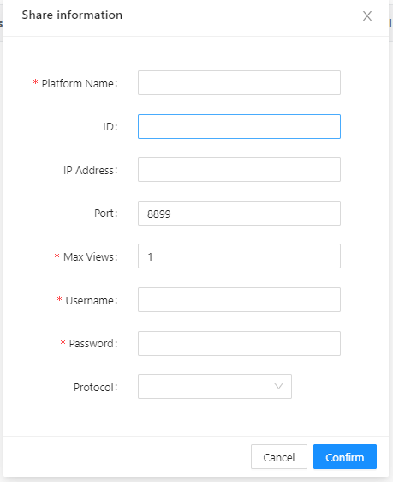

Figure 2-15

1. Platform name as required. ID, IP address, port, user name, and password are assigned to the video cloud platform
2. You can modify or delete configurations of this leve
3. Click the display button of channel details to view the channel information pushed by the subordinate platform

#### Cascading Push

Configure the upper-layer gateway and associated management push channel information, as shown in Figure 2-16 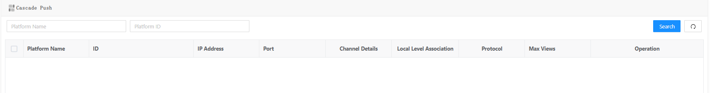

Figure 2-16

1. Click Add. The upper-layer platform information configuration page is displayed, as shown in Figure 2-17

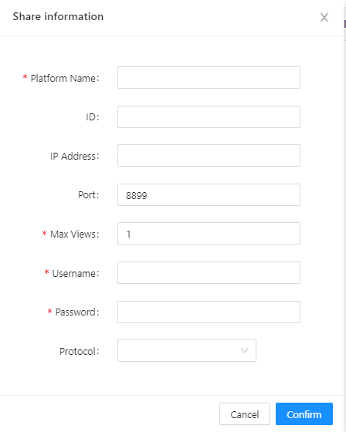

Figure 2-17

1. Enter the platform name as required. The ID, IP address, port number, user name, and password are assigned to the upper-layer platform
2. Modify and delete configurations
3. Click Bind this level. The level configuration information is displayed. Bind this level information to the cascading service
4. Click the associated channel, and the Shared channel page will pop up. You can push the directory and channel to the superior platform respectively. The external coding of the channel must conform to the national standard coding rules. Figure 2-18.

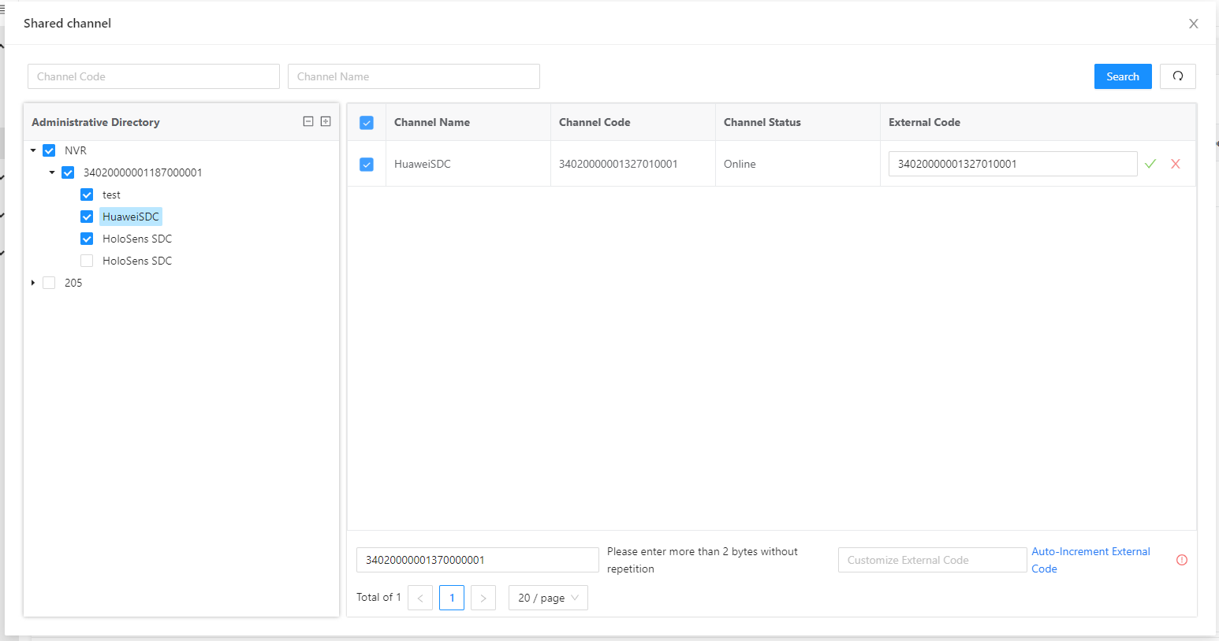 Figure 2-18

### Storage Configuration

#### Real-time Storage Policy

shows how to manage central storage policies.Figure 2-19：

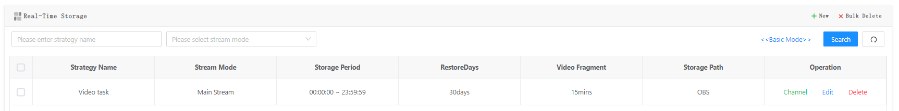

Figure 2-19

1. Click Add Policy. The Add Policy page is displayed, as shown in Figure 2-20
2. Configure the code stream mode, video period, storage time, and video segment, and support video OBA-level storage and OBS cloud storage
3. After the policy is added, click Associate Channel to associate the channel with the real-time storage policy
4. Go to the Configuration Center - Service Management-MSS page. In the lower right corner of the real-time storage page, you can associate real-time storage policies with services to save channel videos

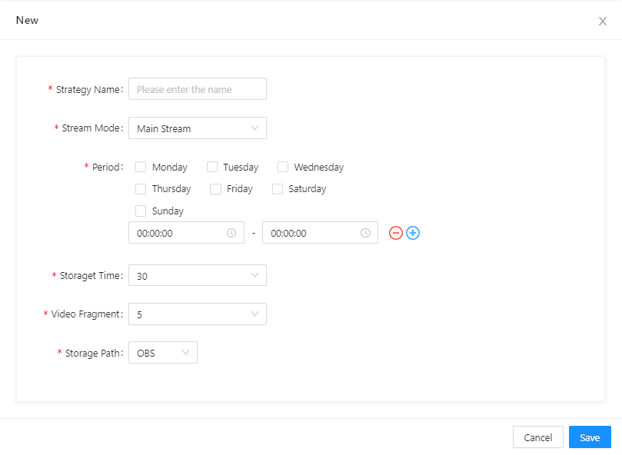

Figure 2-20

#### Video supplementary recording Strategy

Record the video in the front end of the management system to the central storage policy, as shown in Figure 2-21 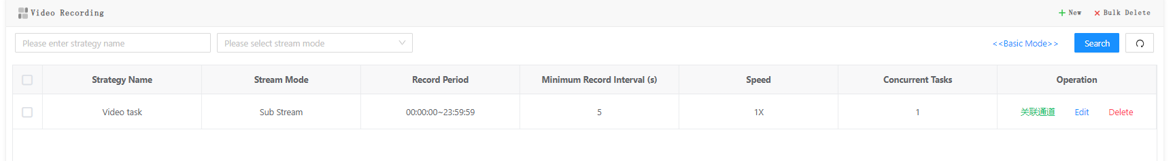

Figure 2-21

1. Click Add Policy. The Add Policy page is displayed, as shown in Figure 2-22：
2. Set the code stream mode, record period, time range, record speed, and number of concurrent tasks
3. After the new policy is added, click the associated channel to associate the channel with the supplementary policy
4. Go to the Configuration Center - Service Management-MSS page. In the lower right corner of the page, you can complete the recording of the channel

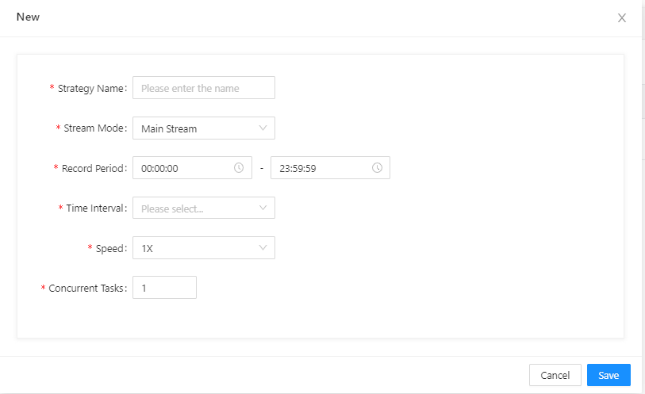

Figure 2-22

### Live broadcast management

Address of the live broadcast platform of the management system, as shown in Figure 2-23

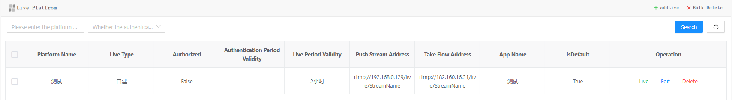

Figure 2-23

Click "Add Live Broadcast" to configure the platform information, as shown in Figure 2-24

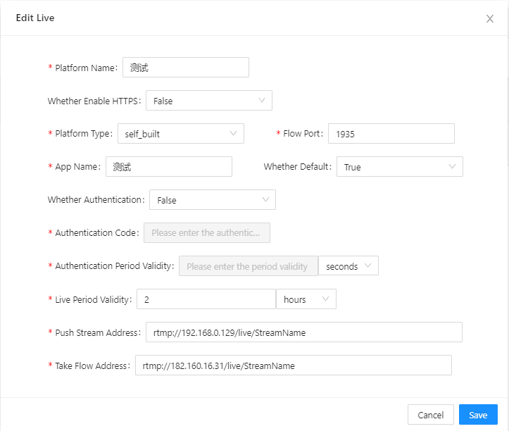

Figure 2-24

Click "Live Stream List" to view the details of the live stream

### Configuring the Network Domain

#### Device Domain

In dual-network mode, if the webcam and network video recorder are configured on the extranet, the channel national standard must be registered with the server. In this case, you need to configure the device domain, as shown in Figure 2-25. The source IP address is the Intranet IP address of the agent service, and the destination IP address is the extranet IP address of the agent server 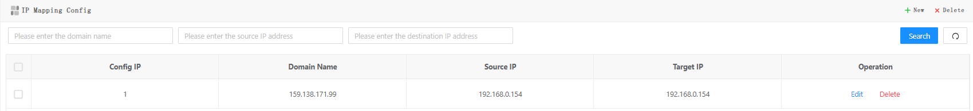

Figure 2-25

#### Client Domain

In dual-network distributed deployment, the server channel communicates over the Intranet, and the client needs to view videos from the Internet, configure the client domain, as shown in Figure 2-26. The internal IP address is10.139.3.19 , and the external IP address is 41.0.66.102

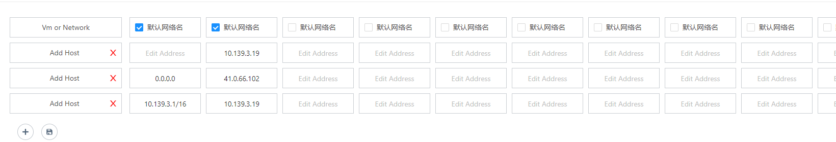

Figure 2-26

## System Configuration

### Rights Management

#### Menu Management

The administrator account can edit the menu information, including the menu directory structure, menu ICONS, and menu names, as shown in Figure 2-27

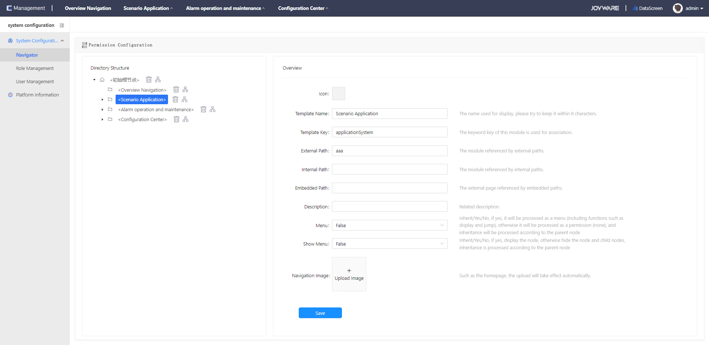

Figure 2-27

#### Role Management

You can add a system role, as shown in Figure 2-28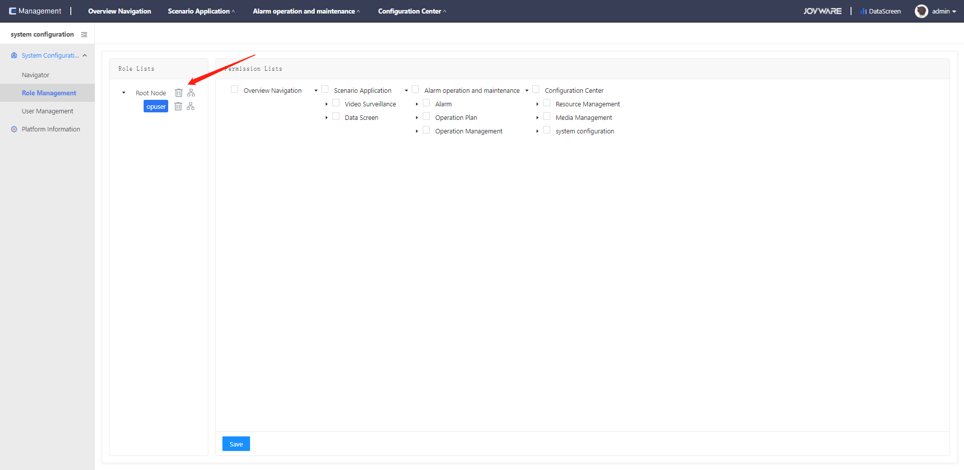

Figure 2-28

Select the role to assign corresponding menu permissions, as shown in Figure 2-29

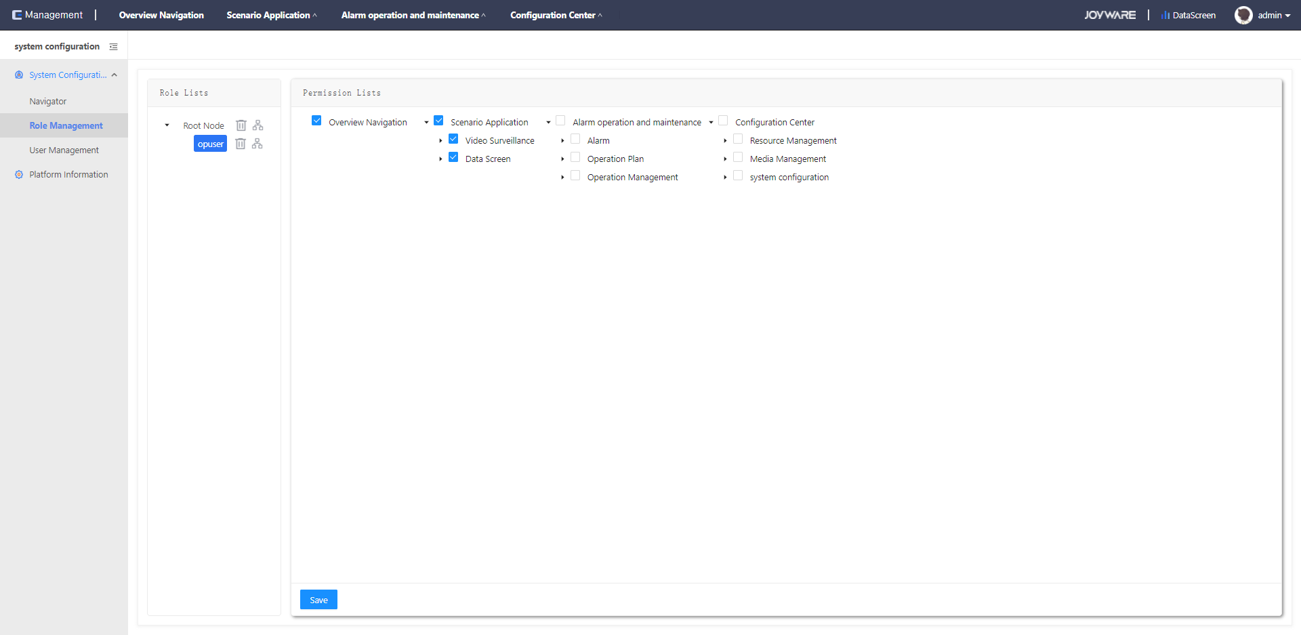

Figure 2-29

#### User Management

Click to add a user group, as shown in Figure 2-30:

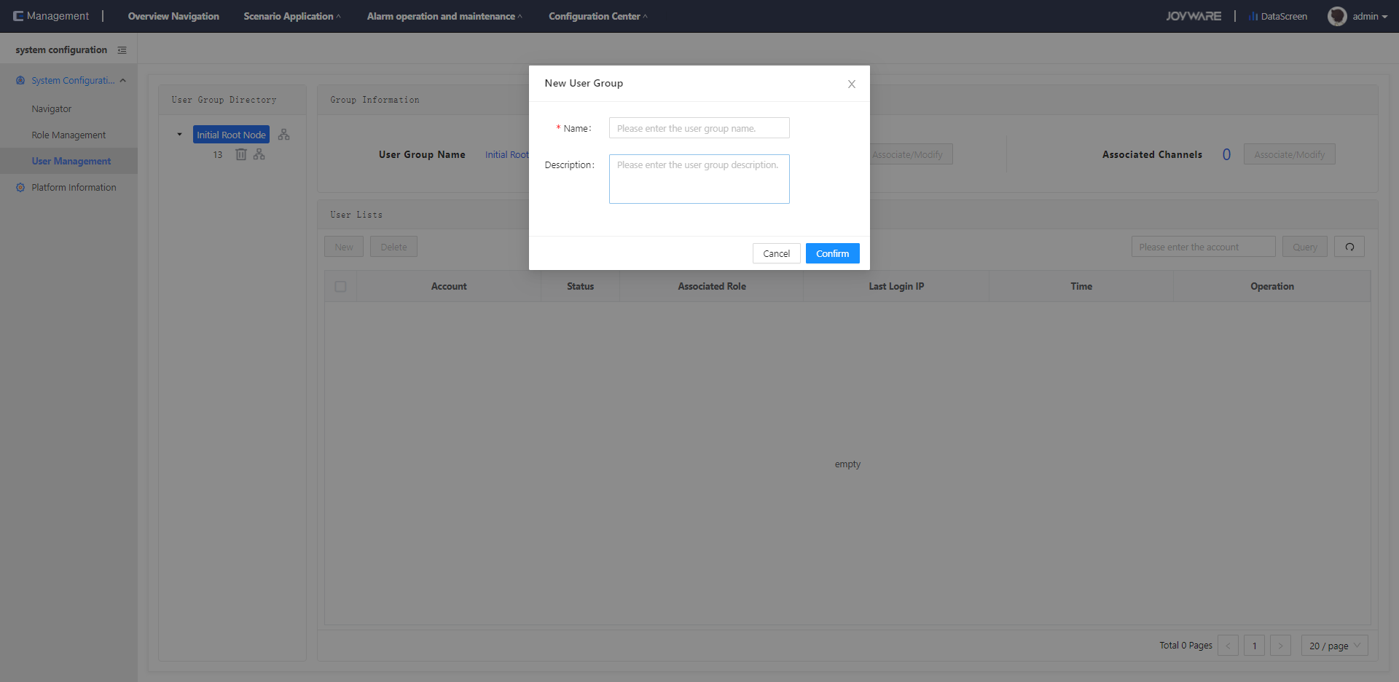

Figure 2-30

Select a user group and associate it with the corresponding administrative region and device, as shown in Figure 2-31-1 and 2-31-2

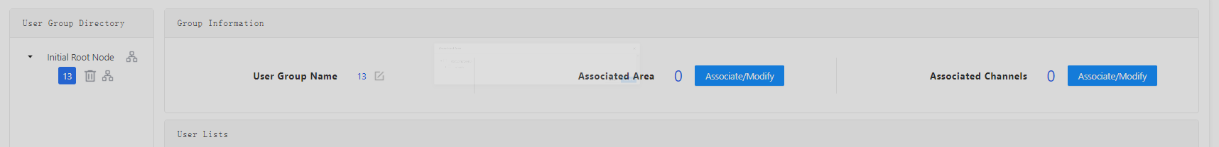

Figure 2-31-1

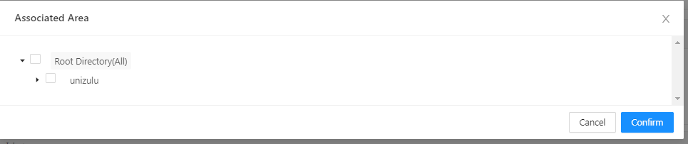

Figure 2-31-2

You can manage user information in the user list, as shown in Figure 2-32

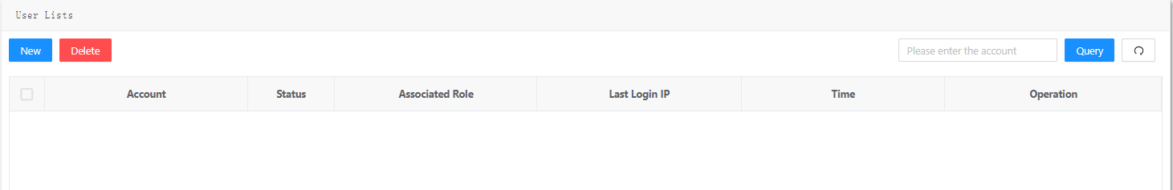

Figure 2-32

### Configuring Platform Information

You can configure the platform web page information, such as the logo and name, as shown in Figure 2-33

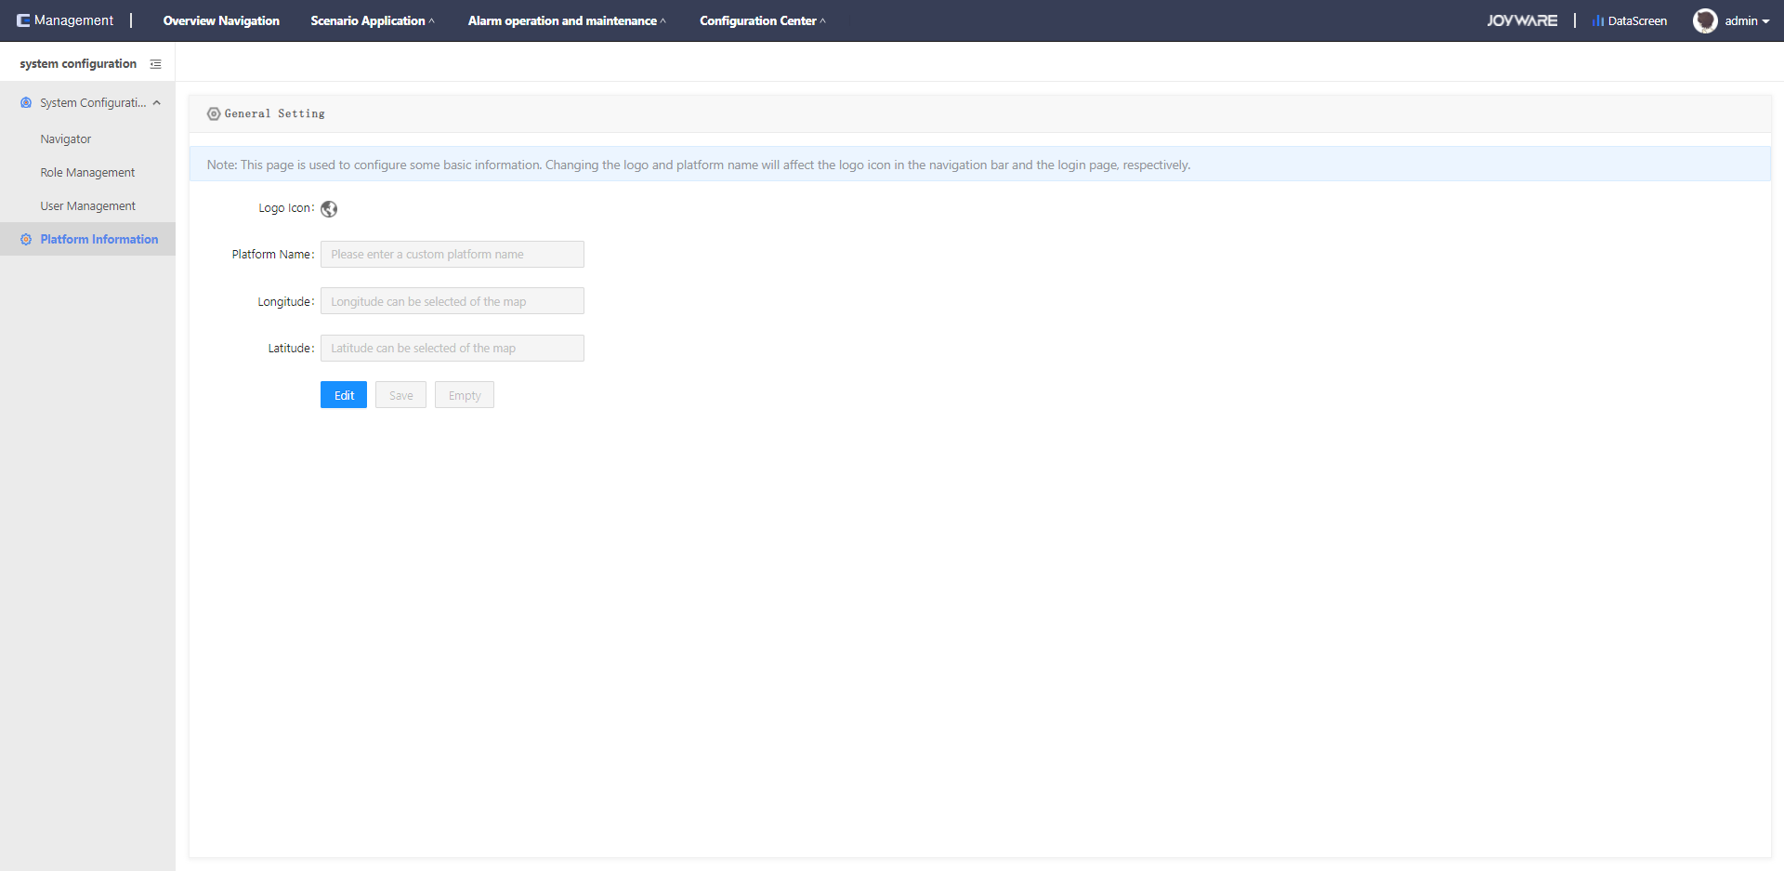

Figure 2-33

# Scenario Application

After completing related configurations, such as adding system devices, you can directly access related applications.

## Video Surveillance

### Real-time Video

As shown in Figure 3-1, the administrative tree is displayed on the left. Expand the tree to view all added channels. You can query channels by channel name. On the right is the real-time video window, where you can view the video channel under the node. You can drag or double-click to play the real-time video, and you can play the real-time video in single, four, or six frames.

According to the selected equipment model, you can control the direction of the gimbal equipment, and support the zoom and zoom. During playback, you can capture pictures, manually record videos, play videos in full screen, and play, pause, and stop videos.

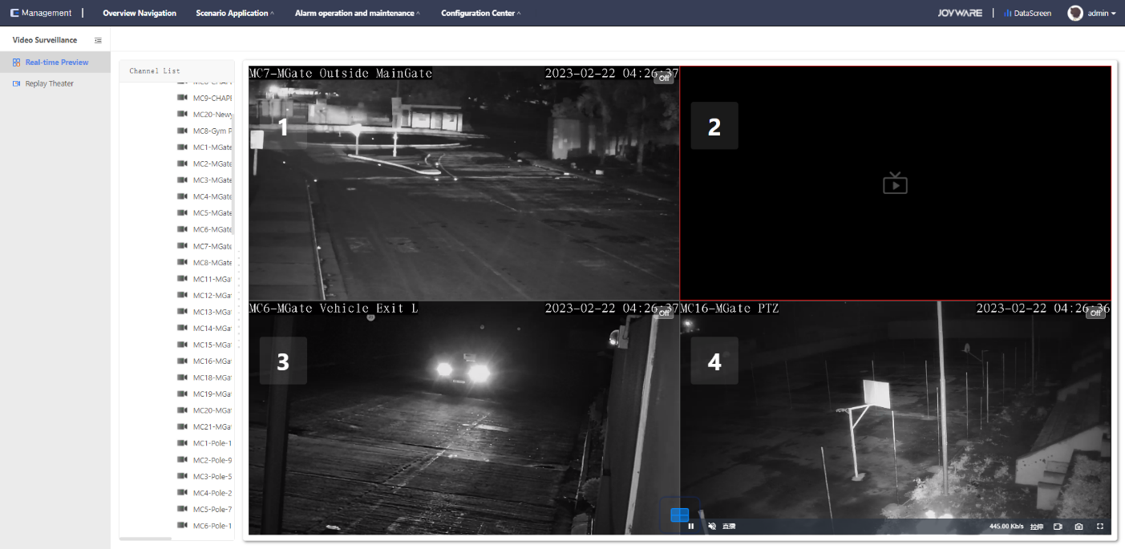

Figure 3-1

### Video Playback

Tap Scenario-Video Surveillance-Video Playback to enter the Video playback screen, as shown in Figure 3-2

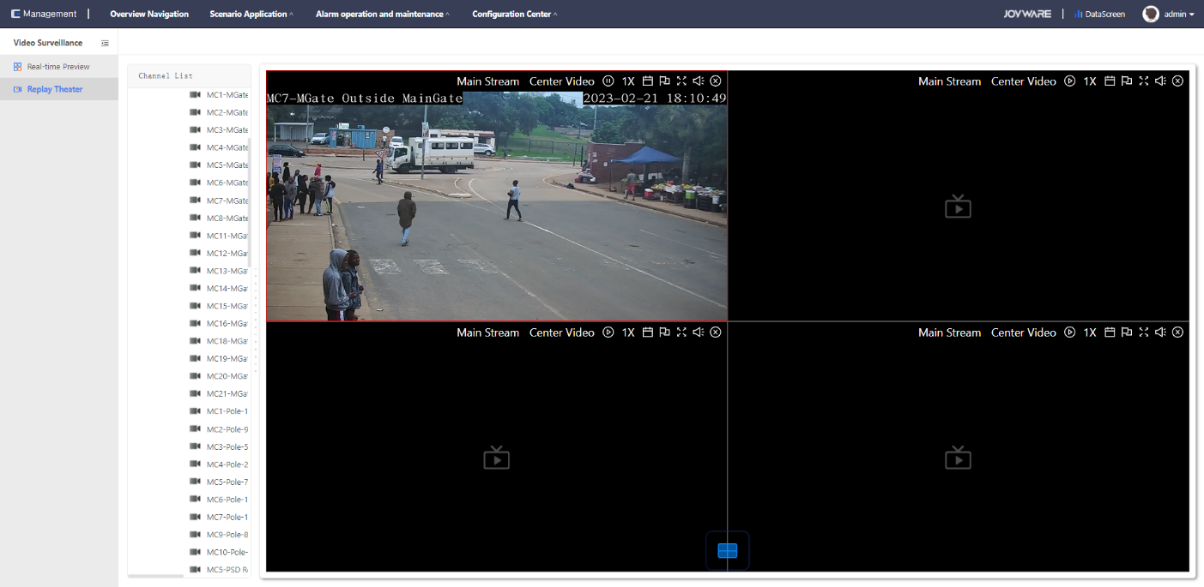

Figure 3-2

As shown in Figure 3-3, the administrative tree is displayed on the left. Expand the tree to view all added channels. You can query channels by channel name. On the right is the video playback window, where you can view the videos of the channel under the node. You can drag or double-click to play real-time videos Supports single - and four-screen playback.

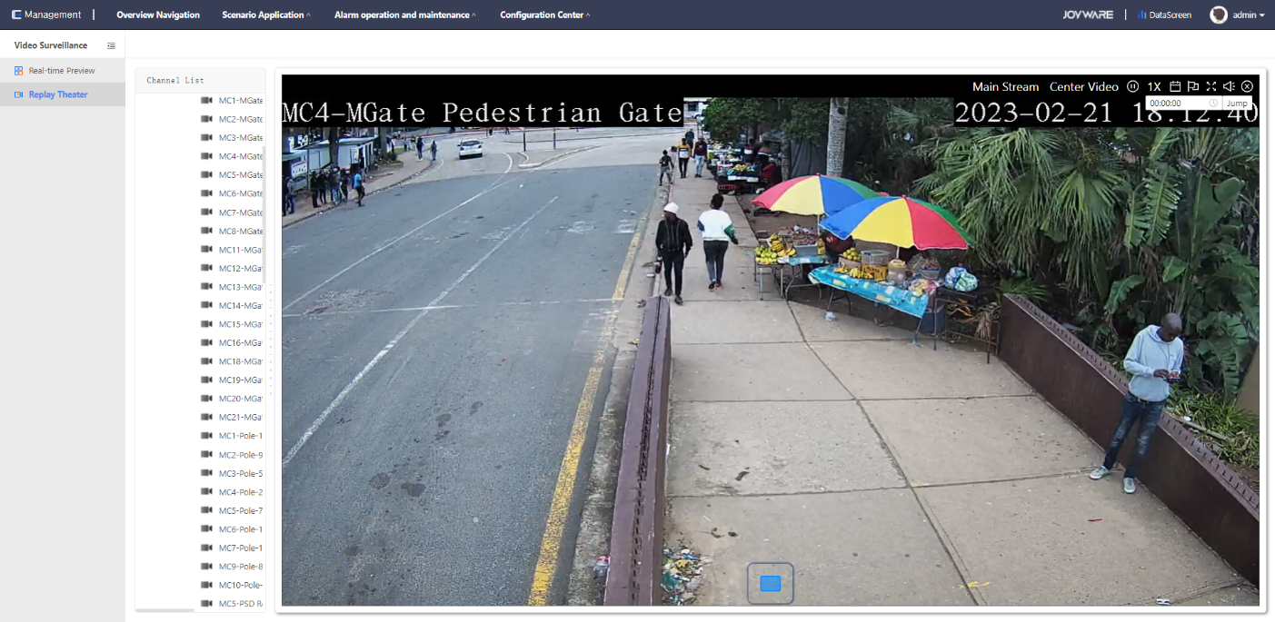

Figure 3-3

1. Double-click or drag a specified video channel to play the video file of the current day.
2. Select the video storage location; "Front-end video" represents the video stored on the front-end device or platform, and "central video" represents the video stored on the cloud.
3. clickButton to pause video playback;
4. clickButton, you can play video slow and fast
5. clickButton to view the video according to the log,click可以设置时间，进行时间定位播放；；
6. clickButton, the class will play the video full screen, click again or keyboard esc key to exit the full screen

# Alarm operation and maintenance

## Operation and Maintenance Plan

### Configuring a Task Plan

Configure Alarm O&M, O&M Plan, and Task Plan, as shown in Figure 4-1. Create an O&M plan and enable it to start the configured O&M task

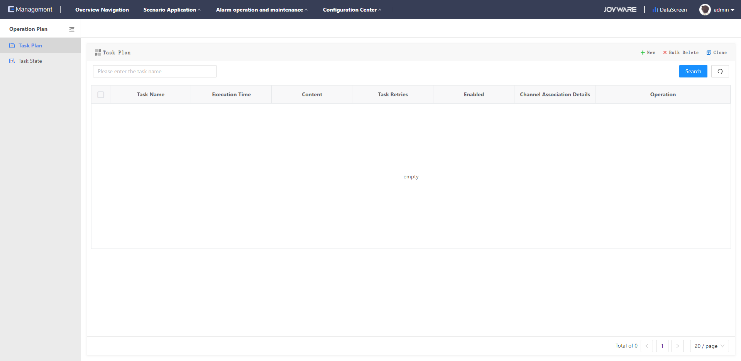

Figure 4-1

1. Create a plan: Add a new O&M task
2. Batch deletion: Delete created O&M tasks in batches
3. Replication plan: Use the replication function when multiple task plans of the same type need to be created
4. You can query existing O&M tasks by task name

Create a video integrity task, set the plan name as required, set the execution content to video integrity, set the retry times to the number of times that a task fails to be executed when no task is on the channel, and set the retry interval to the interval for the task to be executed again. The execution time can be set weekly, as shown in Figure 4-2:

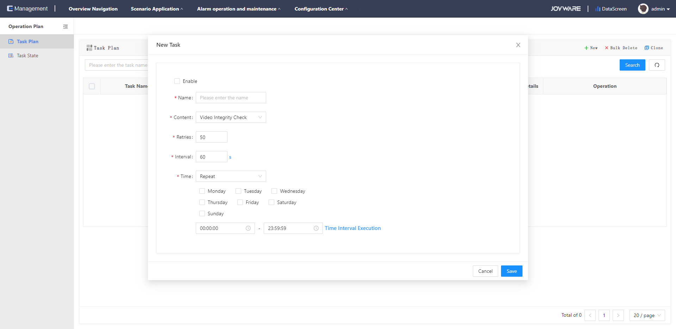

Figure 4-2

After a video integrity task is created, click Associated Channel to associate the video channel that you want to perform this task. Click channel association details to view all associated channels. Click Generate Task, and the task starts to be executed as planned 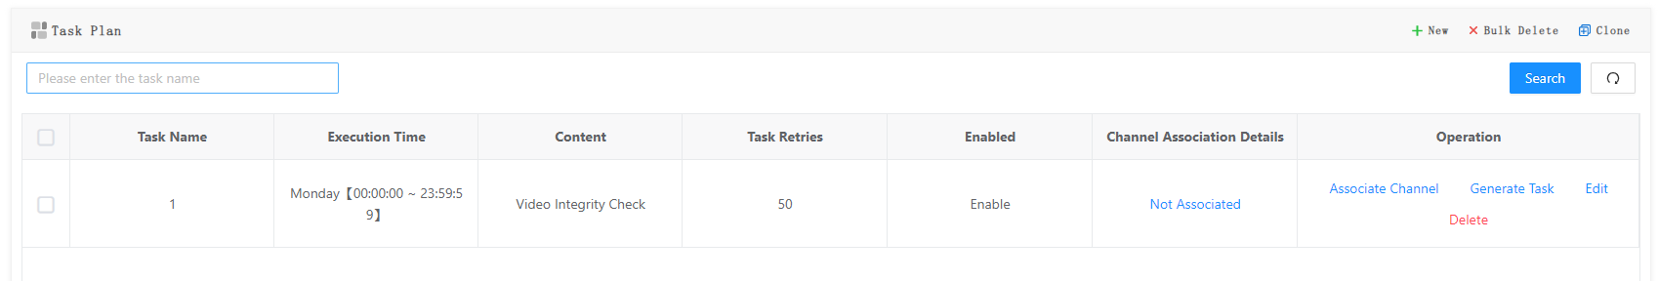

Figure 4-3

The channel online rate is the default task. The check is performed once an hour. You do not need to configure a task plan.

### Task Status

The Alarm O&M - O&M Plane-Task Status page is displayed, as shown in Figure 4-4. Click Execute Task. The task can be executed again.

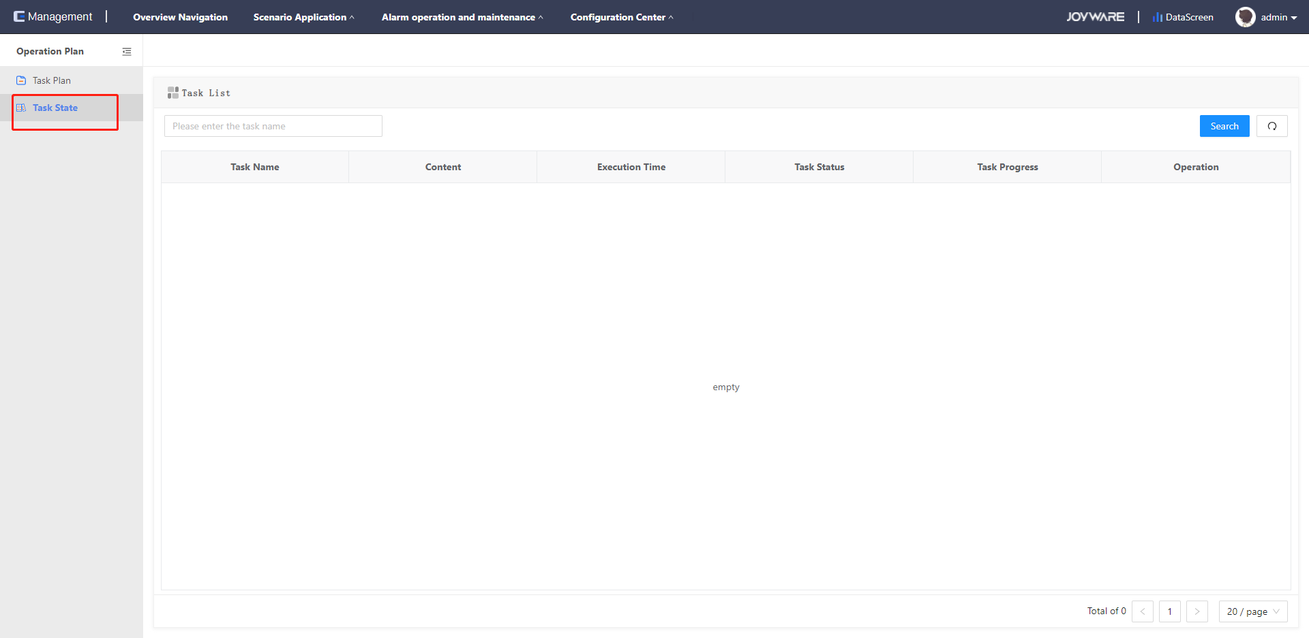

Figure 4-4

### Channel Online Rate

You can view the online status of the channels in the corresponding administrative region. On this page, you can check the online status of all channels in real time, as shown in Figure 4-5 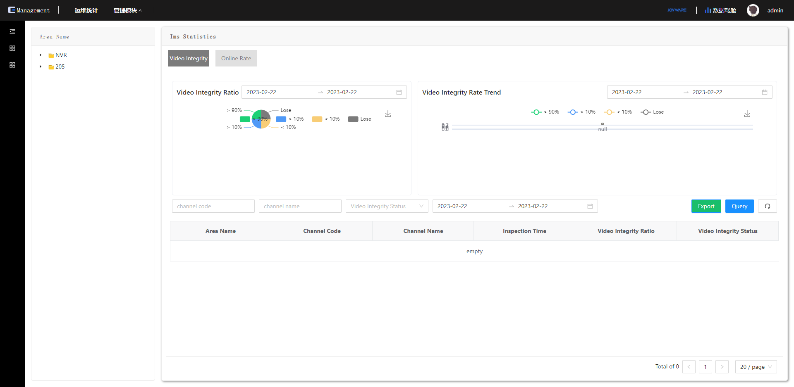

Figure 4-5

### Video integrity

You can query the results of all video completion operations and maintenance tasks. You can set the time range for viewing, set the channel code and channel name for viewing the video integrity of the channel, and view the video integrity results by category. The operation and maintenance results are statistically analyzed and displayed as pie charts and line charts, as shown in Figure 4-6:

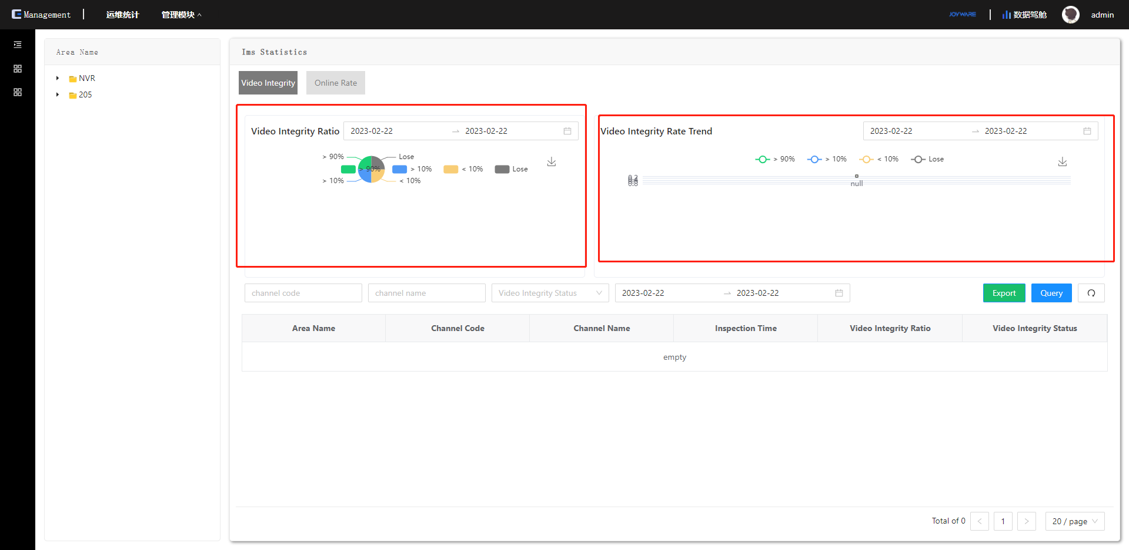

Figure 4-6